“InvestSphere”

A PROJECT REPORT
SUBMITTED BY
Soni Anant Rajeshbhai (ET24MTCA064)

UNDER THE GUIDANCE OF
Prof. Zankhana Vaishnav

In fulfilment for the award of the degree

Of
Master of Computer Applications
At



Sarvajanik College of Engineering and Technology, Surat.
Sarvajanik University

May, 2026
Department of Computer Applications


Sarvajanik University
Sarvajanik College of Engineering & Technology, Surat.
Academic Year: 2025-26

Date: 02/05/2026

CERTIFICATE

This is to certify that the project entitled “InvestSphere” has been submitted by Soni Anant Rajeshbhai (ET24MTCA064) towards the fulfilment of the degree of Master of Computer Applications (M.C.A) in (4th Semester) of Sarvajanik University, Surat during the academic year 2025-2026.

Dr. Gayatri Kapadia
(Head- Department of Computer
Applications)

Prof. Zankhana Vaishnav

(Guide’s Signature)

Examiner’s Signature

- ________________
- ________________
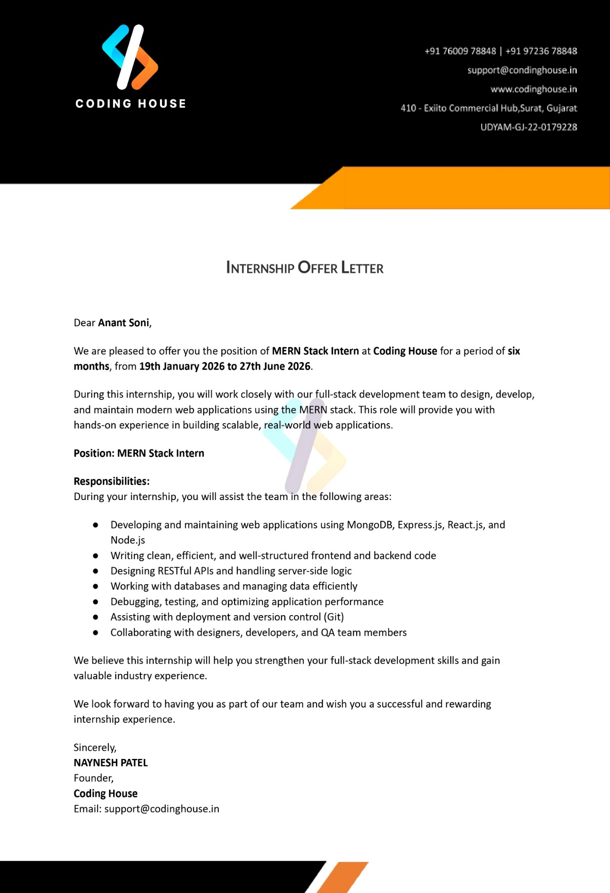
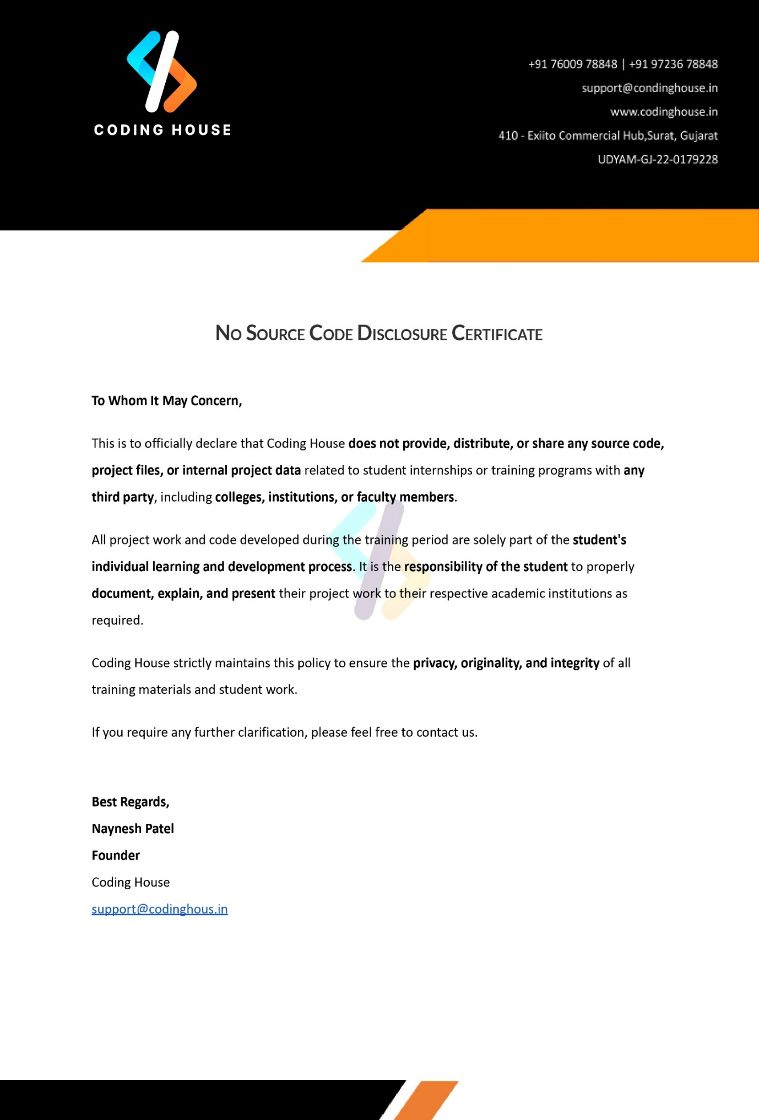

Self Declaration

Title of the project: InvestSphere

Enrolment Number | Student Name
ET24MTCA064 | Soni Anant Rajeshbhai

I hereby declare that the above-mentioned project report submitted by me/us has been prepared by me/us and is original in its content and it has not been submitted anywhere else.

I confirm that the report is only prepared for academic requirements, not for any other purpose.
It might not be used by anyone for any other purpose.

Student’s Signature
Anant Soni

Acknowledgement

The success and final outcome of this project required a lot of guidance and assistance from many people and we are extremely fortunate to have got this all along the completion of our project work. Whatever we have done is only due to such guidance and assistance.

We would not forget to thank Dr. Gayatri Kapadia, Head of Department and Project guide Prof. Zankhana Vaishnav, and all other Assistant professors of Sarvajanik College of Engineering & Technology, Surat. Who took keen interest on our project work and guided us all along, till the completion of our project work by providing all the necessary information for developing a good system.

We are extremely grateful to her for providing such a nice support and guidance though she/he had busy schedule managing the college dealings.

We are thankful and fortunate enough to get support and guidance from all Teaching staffs of Master of Computer Application Department which helped us in successfully completing our project work. Also, we would like to extend our sincere regards to all the non-teaching staff of Master of Computer Application Department for their timely support.

Thanking to all,

From,
Soni Anant Rajeshbhai (ET24MTCA064)

Index

No. | Content | Page No.
1. | Introduction
 | 1.1. Existing System
 | 1.2. Need for the New System
 | 1.3. Objective of the New System
 | 1.4. Problem Definition
 | 1.5. Core Components
 | 1.6. Project Profile
 | 1.7. Assumptions and Constraints
 | 1.8. Advantages and Limitations of the Proposed System
2. | Requirement Determination & Analysis
 | 2.1. Requirement Determination
 | 2.2. Targeted Users
3 | System Design
 | 3.1. Use Case Diagram
 | 3.2. Class Diagram
 | 3.3. Interaction Diagram
 | 3.4. Activity Diagram
 | 3.5. Data Dictionary
4 | Development
 | 4.1. Coding Standards
 | 4.2. Screen Shots

5 | Agile Documentation
 | 5.1. Agile Project Charter
 | 5.2. Agile Roadmap / Schedule
 | 5.3. Agile Project Plan
 | 5.4. Agile User Story
 | 5.5. Agile Release Plan
 | 5.6. Agile Sprint Backlog
 | 5.7. Agile Test Plan
 | 5.8. Earned-value and burn charts
6 | Proposed Enhancements
7 | Conclusion
8 | Bibliography

- Introduction
Client Panel:

InvestSphere is a modern investment and wealth management platform designed to simplify digital investing through a secure, user-friendly, and technology-driven system. The client panel allows users to register and log in using email OTP verification and password authentication. Additional features such as Forgot Email, Forgot Password, Change Password, Profile Update, and profile image upload through Cloudinary provide a complete and reliable account management experience. All user data is securely stored and managed through an organized database structure. The platform enables users to explore multiple investment categories including Stocks, IPOs, SIP Plans, and Cryptocurrency. The stock module provides company-wise listings with detailed information pages for better understanding of market opportunities. IPO data is organized into Upcoming, Ongoing, and Closed categories so users can easily track current and future public offerings. Cryptocurrency integration helps users monitor digital asset trends and price movements in real time.

InvestSphere also provides a smart SIP investment section where users can view organized mutual fund plans, use SIP calculators, receive investment suggestions, and validate start dates and end dates before investing. Reset options and clean plan management tools improve the planning experience and help users make systematic long-term investment decisions with ease. A complete Portfolio Management module is one of the major strengths of the client panel. Users can buy and sell assets, manage wallet balances, view transaction history, track order records, and monitor portfolio growth. Advanced analytics such as Profit & Loss reports, Asset Allocation charts, holdings summary, and performance tracking help users understand returns clearly and make informed financial decisions.

These tools help users analyze their investments efficiently and improve decision-making for future growth. The client panel also includes a personalized Watchlist system where users can save Stocks, IPOs, and SIP plans for future tracking. Watchlist records are linked with the user account for secure personalized access. Real-time market news, live ticker updates, charts, and admin notifications keep users informed about ongoing market conditions. Overall, the client panel delivers a complete digital investment experience that is efficient, organized, and future-ready.
Admin Panel:

InvestSphere includes a professional Admin Panel developed for secure platform control and monitoring. Admin login is protected through Clerk authentication with OTP verification, where only authorized admin email accounts are allowed access. Unauthorized login attempts trigger warning alerts for additional security. After successful authentication, the admin dashboard displays key platform insights such as total users, investments, wallets, transactions, and recent activities through a clean and interactive interface.

The admin can view complete data from all major collections including Users, Stocks, SIP Investments, IPO Investments, Transactions, Wallets, Watchlists, Reports, Notifications, and Messages. Search, filtering, refresh options, pagination, and organized table views are available to improve monitoring and data analysis. The dashboard helps the admin understand platform performance and user activities in a fast and structured manner.

The admin panel also includes a communication system where admins can send messages directly to user email accounts, and those messages are automatically delivered to the user notification section inside the platform. A complete notification management system ensures smooth communication and timely updates. Built with modular backend architecture using routes, controllers, APIs, and database models, the admin panel is scalable, maintainable, and ready for future enhancements such as advanced analytics and smart monitoring tools.

1.1. Existing System

The traditional investment management system often depends on offline processes, fragmented platforms, and manual financial tracking, which can be:
- Time-consuming due to the need to visit brokers, banks, or use multiple sources for investment-related information.
- Complex and confusing for new investors who struggle to understand Stocks, IPOs, SIPs, and other investment options without proper guidance.
- Inefficient in portfolio management, where users manually track profits, losses, transactions, and asset performance using spreadsheets or separate tools.
- Limited in real-time access, making it difficult for users to receive instant market updates, stock movements, and financial news.
- Lack of centralized watchlist and investment tracking, causing users to miss opportunities in Stocks, IPOs, and SIP plans.
- Weak communication systems, where users do not receive direct notifications, updates, or personalized alerts from service providers.

1.2. Need for the New System

An investment management platform like InvestSphere is essential due to:
- Anywhere Accessibility: Users can manage investments, track portfolios, and explore market opportunities from anywhere through an online platform.
- Efficient Investment Management: Users can easily invest in Stocks, IPOs, SIPs, and other assets through a structured and user-friendly system.
- Secure Authentication: The platform uses email OTP verification, password protection, Clerk admin authentication, and role-based access for secure account management.
- Centralized Portfolio Tracking: Users can access portfolio details, wallet balances, transactions, order history, asset allocation, and profit & loss reports in one place.
- Real-Time Market Information: Provides live market data, stock details, ticker updates, market history charts, cryptocurrency trends, and financial news for better decision-making.
- Personalized Watchlist Management: Users can save Stocks, IPOs, and SIP plans for future tracking and investment planning.

1.3. Objective of the New System
- Seamless User Investment Experience: Provide a structured digital platform for exploring, investing, and managing financial assets efficiently.
- Secure Authentication & Access: Implement email OTP verification, password-based login, Clerk admin authentication, and role-based access control for secure usage.
- Efficient Investment Opportunities: Allow users to easily browse and invest in Stocks, IPOs, SIPs, and Cryptocurrency through an organized system.
- Comprehensive Portfolio Management: Enable users to manage wallet balances, buy/sell assets, view transactions, track orders, and monitor Profit & Loss performance.
- Real-Time Market Insights: Provide live stock data, market ticker updates, historical charts, financial news, and cryptocurrency trends for informed decision-making.

1.4. Problem Definition

The investment industry faces challenges such as:
- Limited accessibility to investment services, especially for users who are unfamiliar with traditional financial systems or do not have direct access to brokers and advisors.
- Time-consuming investment processes due to manual research, multiple platforms, and delayed access to market information.
- Difficulty in tracking portfolios including profits, losses, transactions, and asset performance across different investment sources.
- Lack of centralized financial records, making it hard for users to maintain complete investment history over time.
- Insufficient real-time market updates, causing users to miss important opportunities in Stocks, IPOs, SIPs, and Cryptocurrency.
- Weak communication systems between platform administrators and users regarding important notices, updates, or alerts.
- Security concerns in outdated systems due to poor authentication methods and weak account protection mechanisms.
- Limited analytical support, making it difficult for users to understand asset allocation, returns, and overall investment growth.

1.5. Core Components

The InvestSphere platform consists of several interrelated components, each playing a vital role in simplifying digital investment management and portfolio tracking.

1. User Authentication Module:
  - Users can register using email OTP verification for secure account creation.
  - Login system supports email and password authentication.
  - Features include Forgot Email, Forgot Password, Change Password, and Profile Update options.
  - Admin access is protected through Clerk authentication with OTP verification and authorized email control.

2. Investment Exploration Module:
  - Users can explore multiple investment categories such as Stocks, IPOs, SIP Plans, and Cryptocurrency.
  - IPO data is organized into Upcoming, Ongoing, and Closed categories.
  - Stock details pages provide company-wise market information.
  - SIP plans include suggestions and calculator support for better planning.

3. Portfolio Management Module:
  - Users can add investments and manage their complete portfolio digitally.
  - Supports Buy and Sell operations for assets.
  - Displays wallet balance, order records, transaction history, and portfolio summaries.
  - Tracks Profit & Loss performance of investments.

4. Analytics & Reporting Module:
  - Provides Asset Allocation reports for investment distribution.
  - Displays portfolio analytics and performance insights.
  - Helps users understand growth trends and returns clearly.

5. Watchlist Module:
  - Users can save Stocks, IPOs, and SIP plans for future tracking.
  - Personalized watchlist data is linked with the user account.
  - Includes pagination and organized display for better usability.

6. Transaction Management Module:
  - Users can view complete transaction history for all investment activities.
  - Records include Buy, Sell, Deposit, Withdraw, and Wallet transactions.
  - Each transaction stores date, amount, asset type, and status details.
  - Users can track past financial activities in an organized manner.

7. Profit/Loss & Buy/Sell Module:
  - Users can perform Buy and Sell operations for Stocks, IPOs, SIPs, and other assets.
  - System automatically calculates Profit & Loss based on market value and purchase price.
  - Displays realized and unrealized gains/losses clearly.
  - Helps users analyze returns and make better investment decisions.

1.6. Project Profile
Project Name | InvestSphere
Type | Digital Investment & Portfolio Management Platform
Technology Used | - Frontend: React.js + Tailwind CSS  - Backend: Node.js + Express.js  - Database: MongoDB  - Authentication: Email OTP, Password Login, Clerk Admin Authentication  - APIs: Market Data APIs, News APIs, Financial Data APIs  - Media Storage: Cloudinary
Target Users | - Investors: Explore Stocks, IPOs, SIPs, Cryptocurrency, manage portfolio and watchlist.  - Admin: Manage users, notifications, messages, and platform data.
Key Features | - User Registration & Secure Login  - Stocks, IPO, SIP, Crypto Modules  - Portfolio Buy/Sell Management  - Wallet & Transactions  - Profit & Loss Analytics  - Asset Allocation Reports  - Watchlist Management  - Market News & Live Ticker  - Admin Dashboard  - Email & In-App Notifications

1.7. Assumptions and Constraints

Assumptions:
- Users will have stable internet access to use the InvestSphere platform smoothly.
- Users will provide accurate registration details such as email credentials for secure authentication.
- Investors will use the platform responsibly while making investment decisions in Stocks, IPOs, SIPs, and Cryptocurrency.
- Market data, news feeds, and third-party financial APIs will remain available and functional.
- Admin users will manage notifications, messages, and platform operations responsibly.
- User account information, portfolio records, and personal data privacy will be strictly maintained.
- Users will understand that market investments involve financial risk and returns are subject to market conditions.

Constraints:
- Platform performance depends on internet connectivity and external API response times.
- Real-time market prices may vary due to data provider delays or refresh intervals.
- Investment results and returns cannot be guaranteed because of market fluctuations.
- Admin access is restricted only to authorized accounts through secure authentication.
- Some features may require regular maintenance, API updates, or database optimization for continuous performance.

1.8. Advantages and Limitations of the Proposed System

Advantages:

1. Seamless Digital Investment Experience:

● Users can easily explore, invest, and manage Stocks, IPOs, SIPs, and Cryptocurrency through a single platform.

2. Secure Authentication System:

● Email OTP verification, password login, and Clerk-based admin authentication ensure secure user access.

3. Structured Portfolio Management:

● Users can track investments, wallet balances, transactions, buy/sell records, and order history efficiently.

4. Real-Time Market Insights:

● Live ticker updates, market history charts, stock details, and financial news help users make informed decisions.

5. Personalized Watchlist Feature:

● Users can save Stocks, IPOs, and SIP plans for future monitoring and planning.
Limitations:

1. Internet Dependency:

● A stable internet connection is required for smooth access to live market data and platform features.

2. Market Risk Dependency:

● Investment returns cannot be guaranteed because they depend on market fluctuations.

3. Third-Party API Dependency:

● Real-time stock prices, market news, and financial data rely on external APIs.

4. Device Performance Constraints:

● Older devices may experience slower loading speeds or reduced UI performance.

5. Security & Data Privacy Risks:

2.1. Requirement Determination

Functional Requirements:

1. User Authentication:

● Secure email OTP verification for user registration.
● Email and password login system for users.
● Clerk-based secure login system for admin users.
● Forgot Email, Forgot Password, Change Password, and Profile Update features.

2. Investment Exploration & Management:

● Users can explore Stocks, IPOs, SIP Plans, and Cryptocurrency data.
● IPO categories include Upcoming, Ongoing, and Closed IPOs.
● Users can view stock details and investment information.
● SIP calculator and planning tools are available.

3. Portfolio Management:

● Users can add investments to their portfolio.
● Supports Buy and Sell operations for assets.
● Displays wallet balance, transaction history, orders, and portfolio records.
● Tracks Profit & Loss performance.

4. Watchlist Management:

● Users can save Stocks, IPOs, and SIP plans for future tracking.
● Personalized watchlist linked with the user account.

5. Market Data & News:

● Displays live ticker data, market history charts, and financial news.
● Provides updated market trends for better investment decisions.

Non-Functional Requirements:
- Performance:
● Fast loading of market data, portfolio records, and investment modules.
- Usability:
● Intuitive and responsive UI/UX for investors and administrators.
- Scalability:
● Supports growing numbers of users, portfolios, and market data requests.
- Reliability:
● Minimal downtime to ensure continuous platform availability.
- Security:
● Strong authentication and secure handling of user and financial data.

2.2. Targeted Users:

1. Investors:
● Register securely using email OTP verification.
● Login using email and password credentials.
● Explore Stocks, IPOs, SIP Plans, and Cryptocurrency opportunities.
● View stock details, IPO categories, SIP suggestions, and market trends.
● Add Stocks, IPOs, and SIP plans to personalized watchlists.
● Buy and sell assets through the portfolio management system.
● Manage wallet balance, transactions, and order history.
● View Profit & Loss reports, Asset Allocation, and portfolio analytics.
● Receive notifications and important updates from the admin panel.

2. Administrators:
● Login securely using Clerk authentication with authorized admin access.
● View user data and platform records directly from the database.
● Manage notifications and communication with users.
● Send messages directly to user email accounts.
● Monitor platform activities and maintain smooth system operations.
● Manage overall administrative controls through a structured dashboard.

3. System Design

3.1. Use Case Diagram

Client Use Case Diagram :

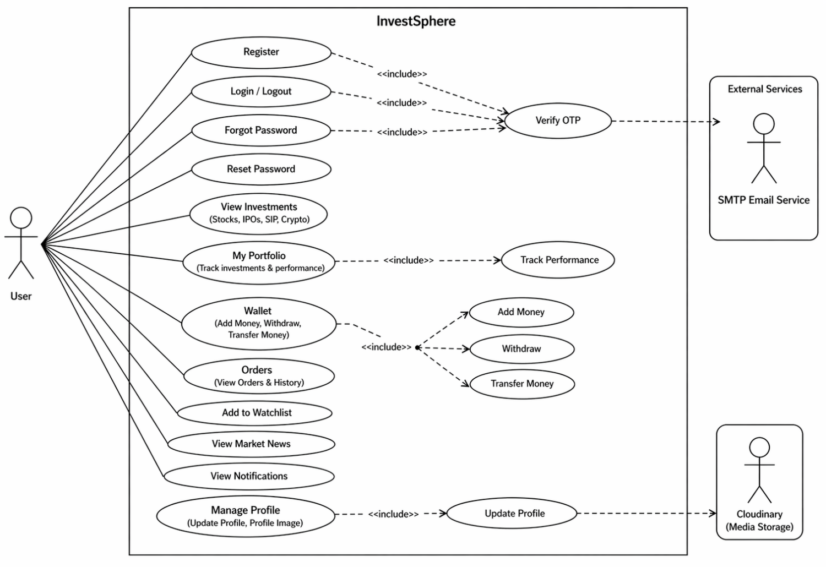

Admin Use Case Diagram:

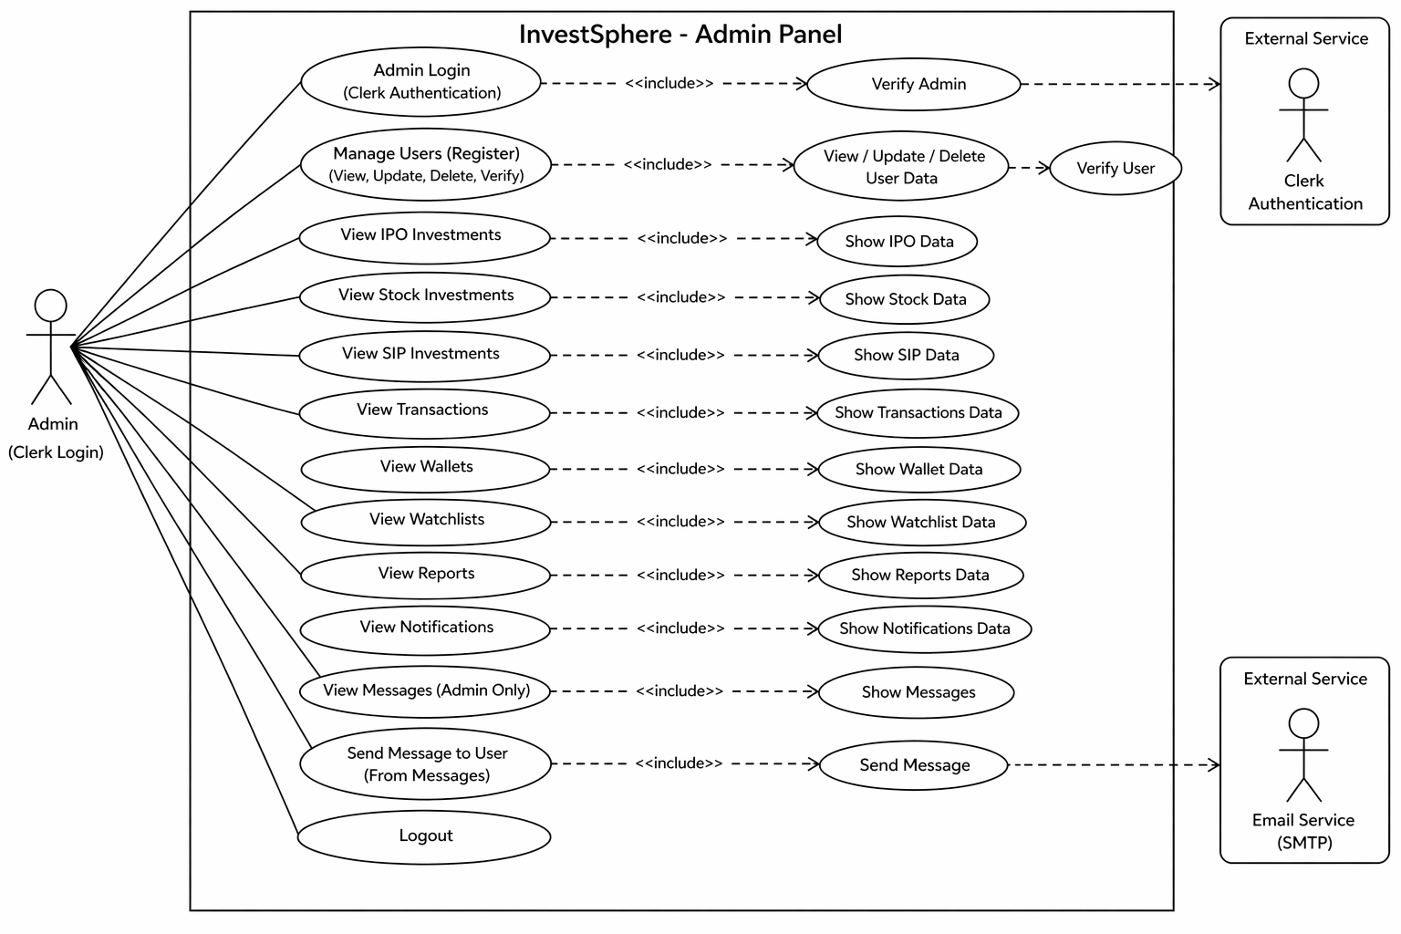

3.2. Class Diagram

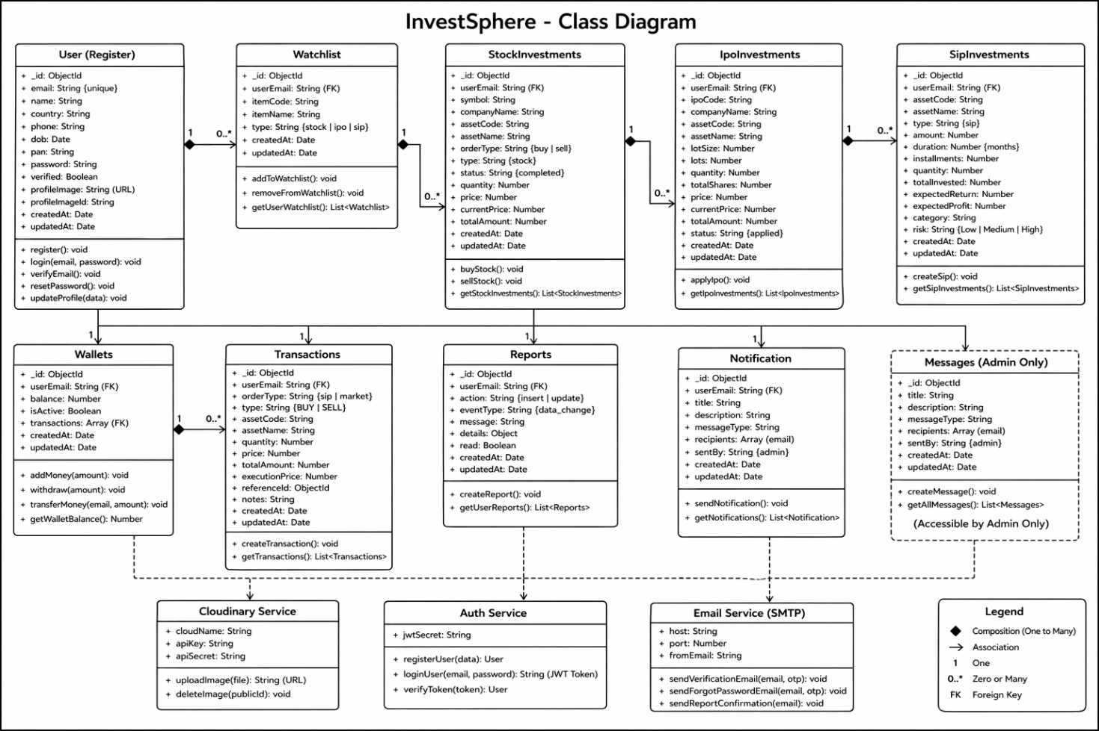
3.3. Interaction Diagram
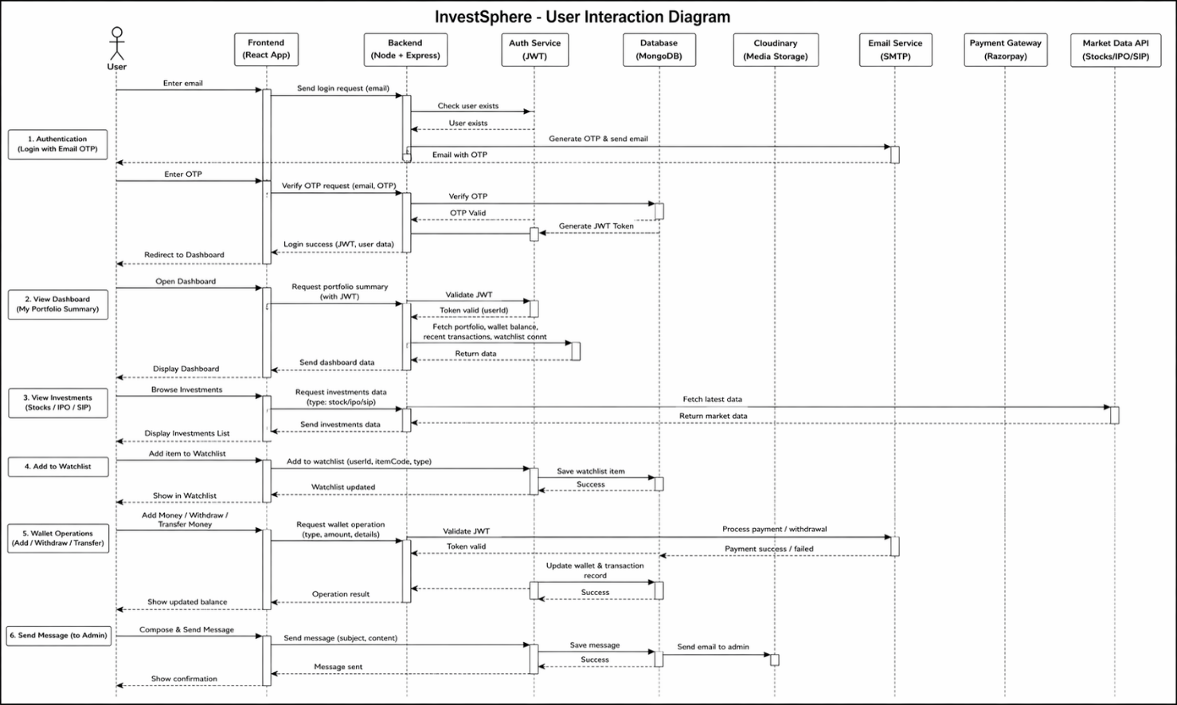

3.4. Activity Diagram

Client Activity Diagram:

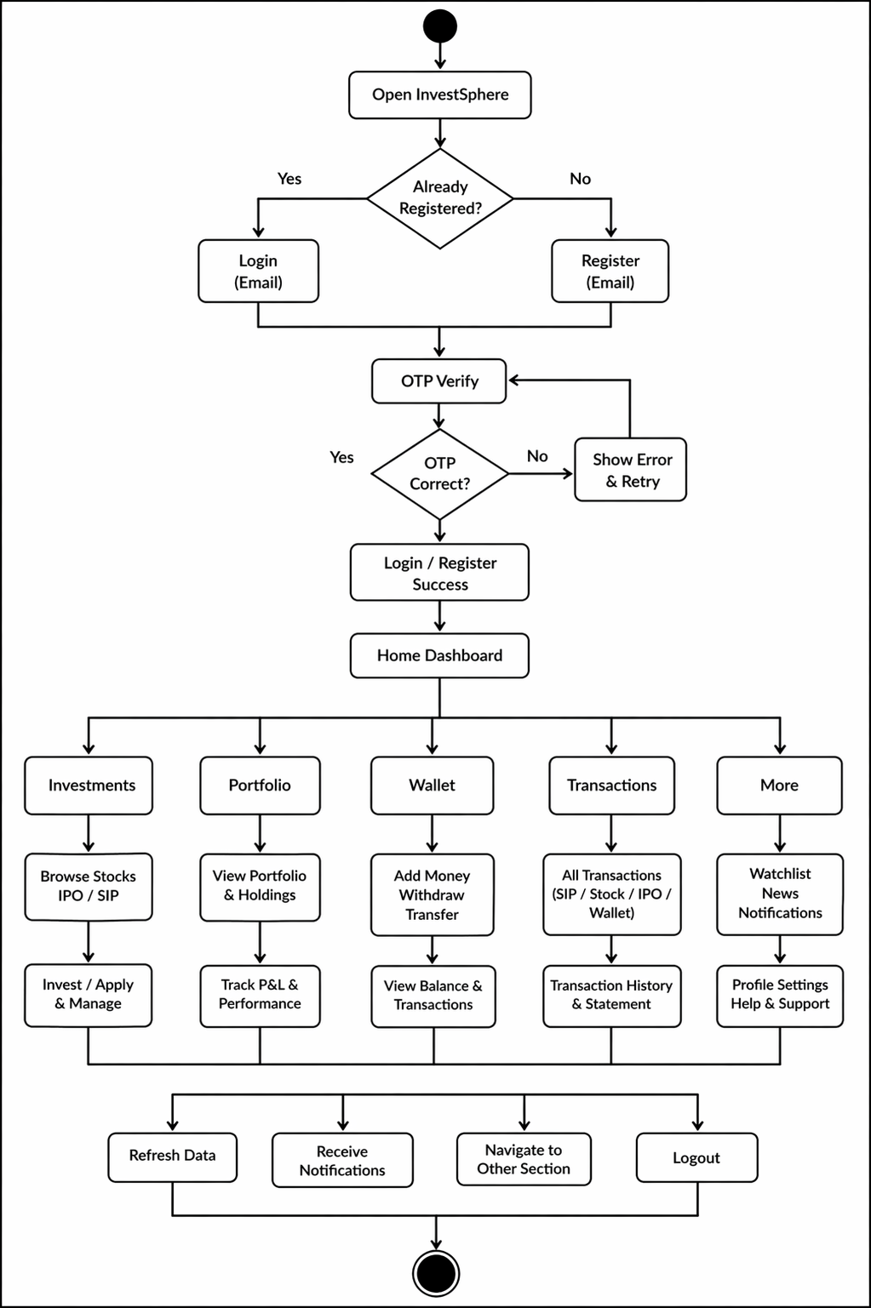
Admin Activity Diagram:
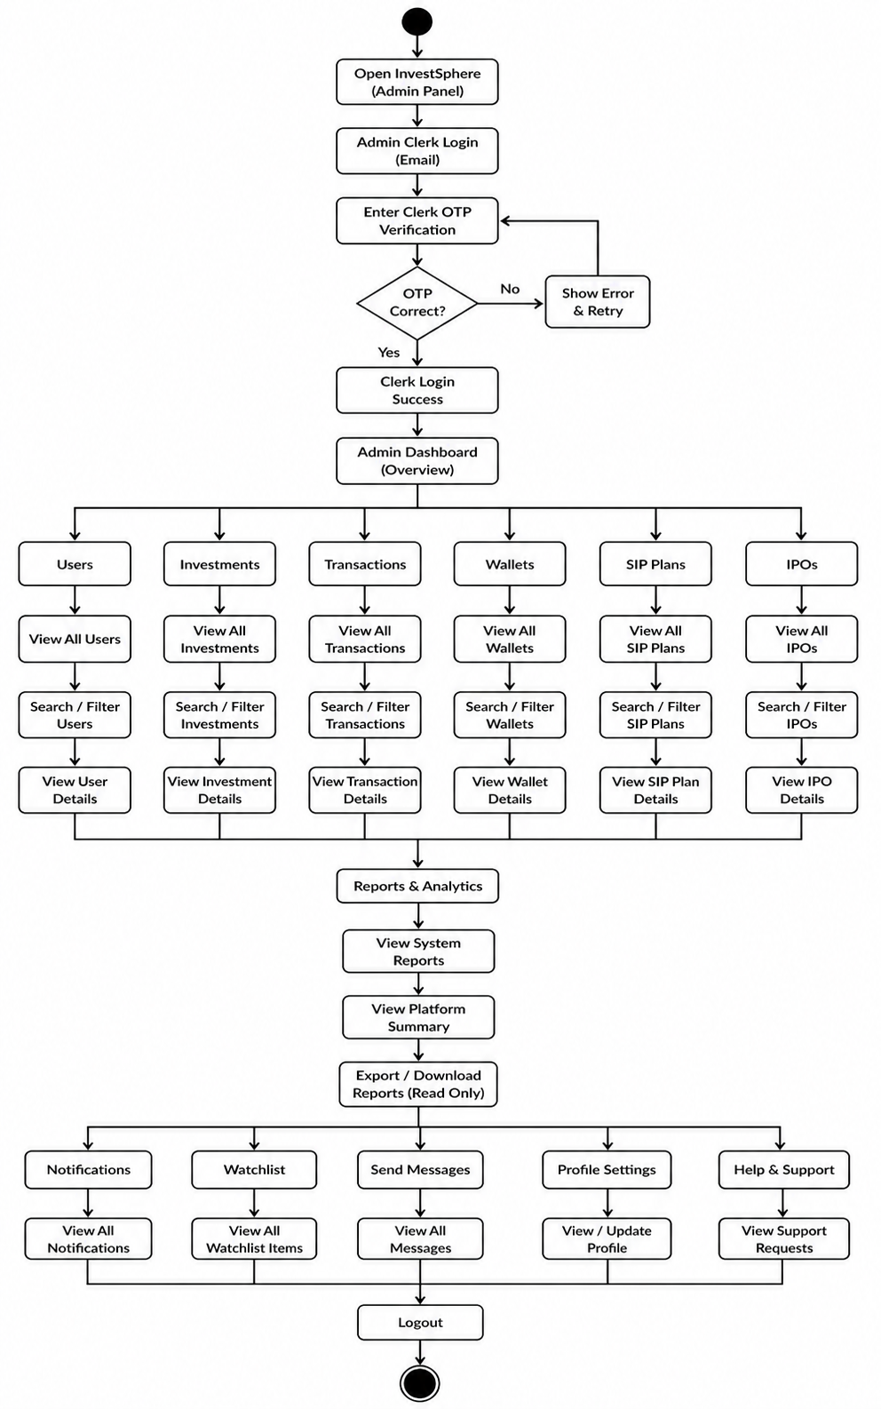
3.5. Data Dictionary

Collection: Register

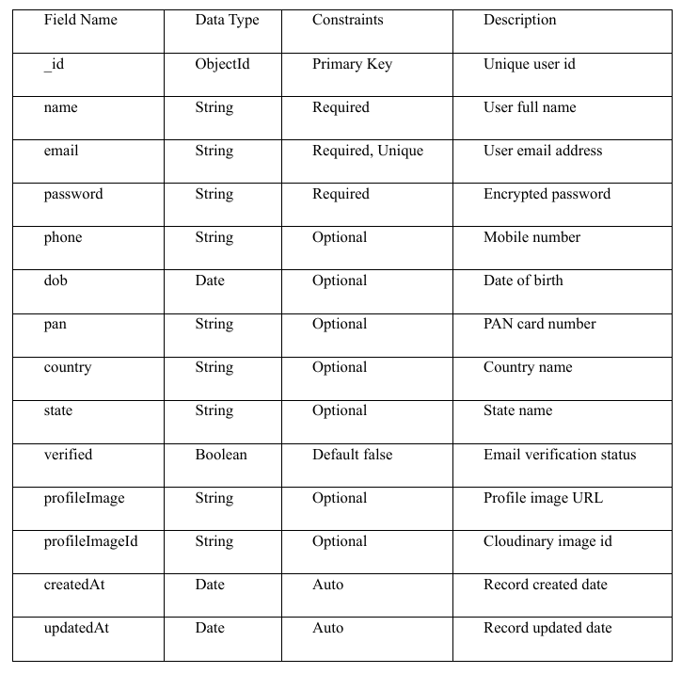

Collection: Watchlists

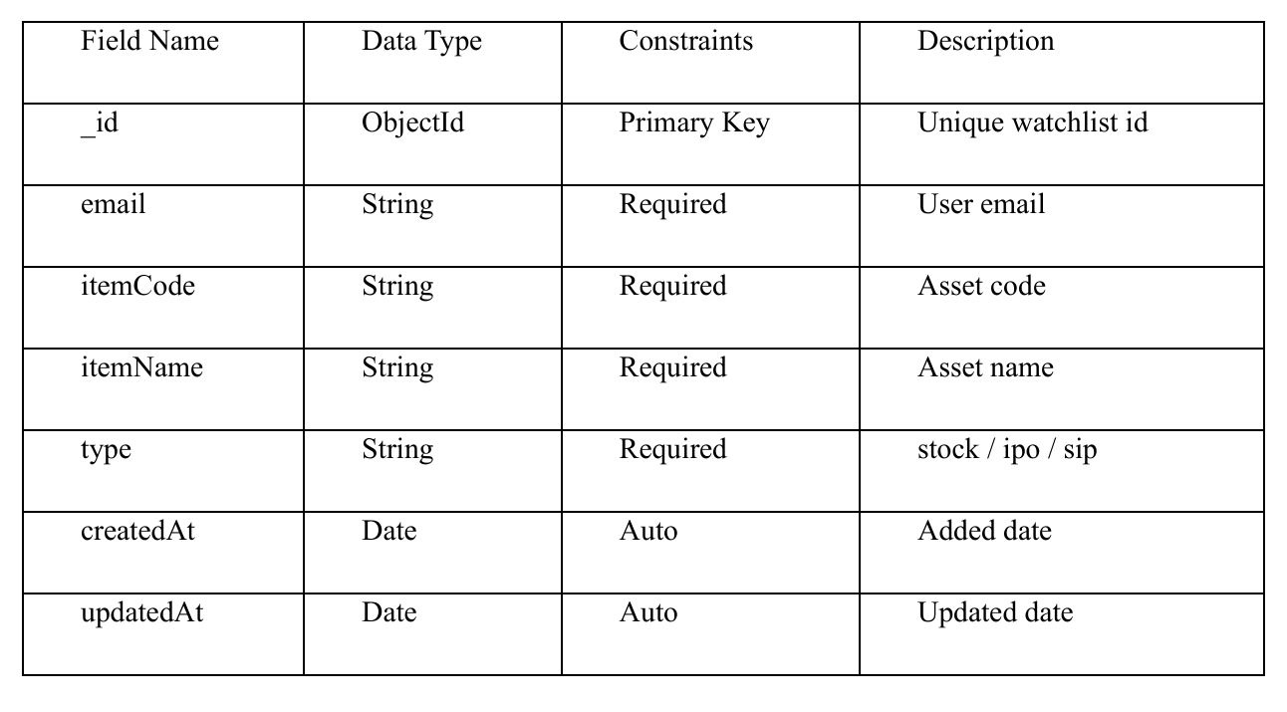Collection: Wallets
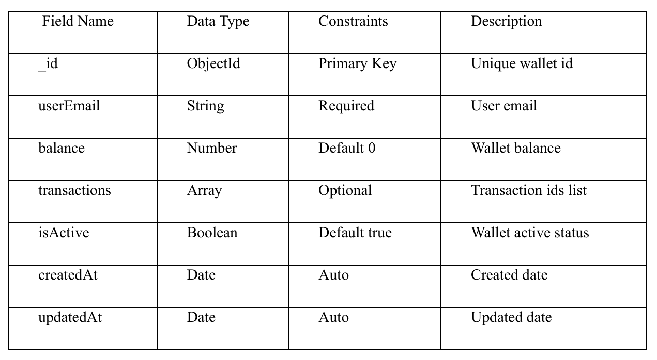

Collection: Transactions

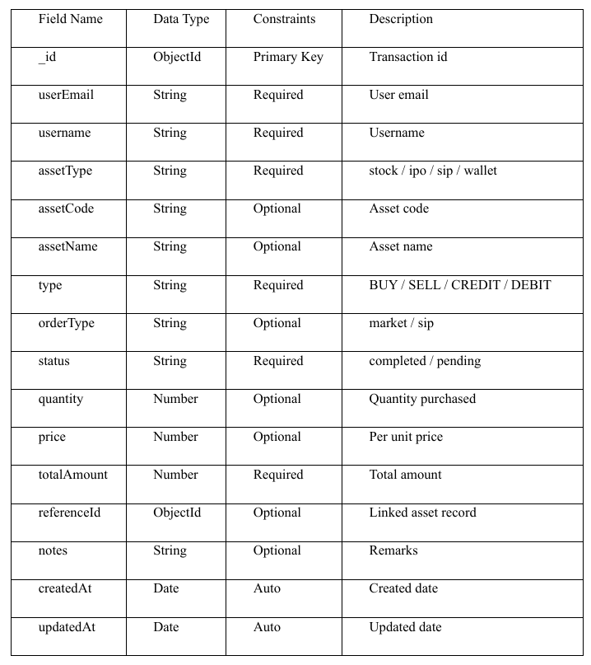

Collection: StockInvestment 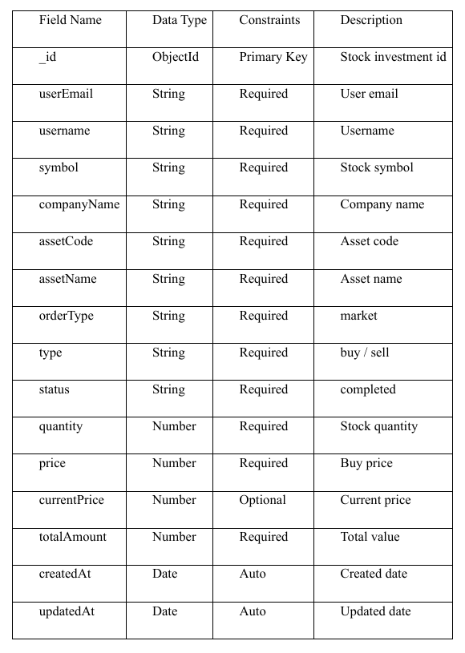

Collection: IpoInvestments

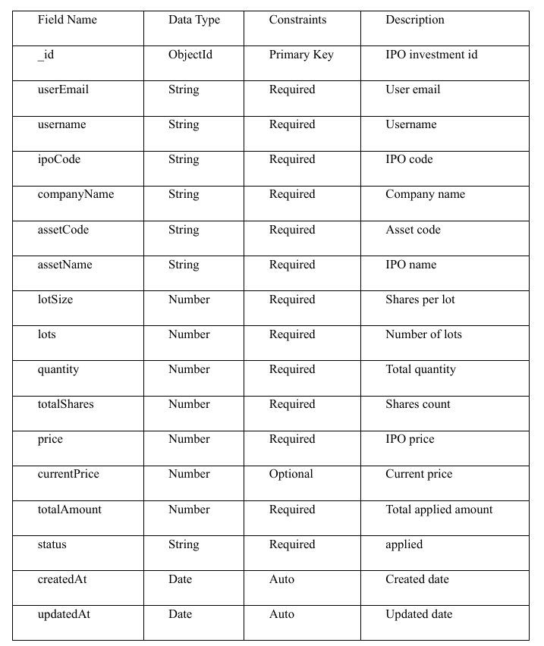
Collection: SipInvestments
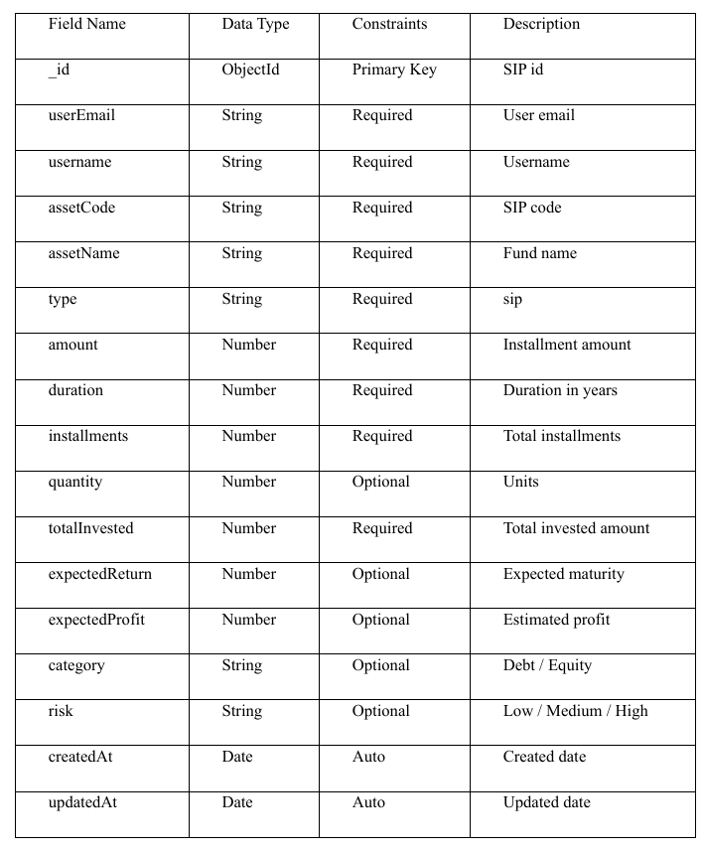

Collection: Reports

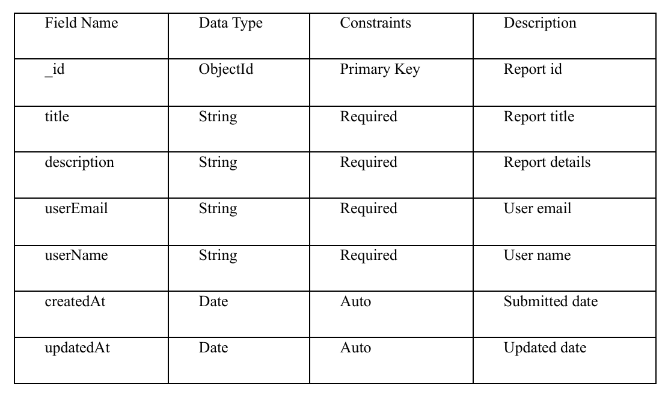

Collection: Notification

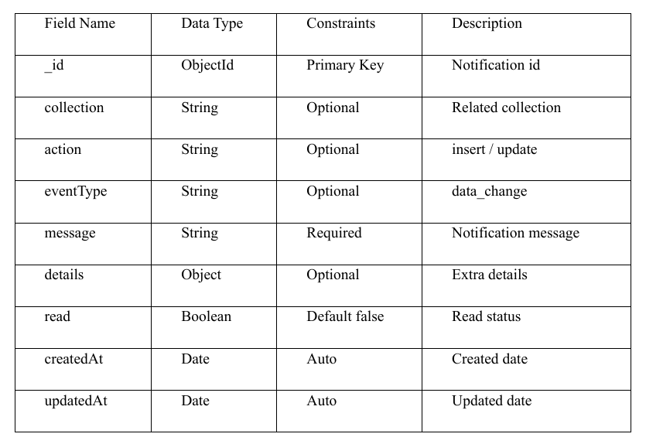
Collection: Messages (Admin)

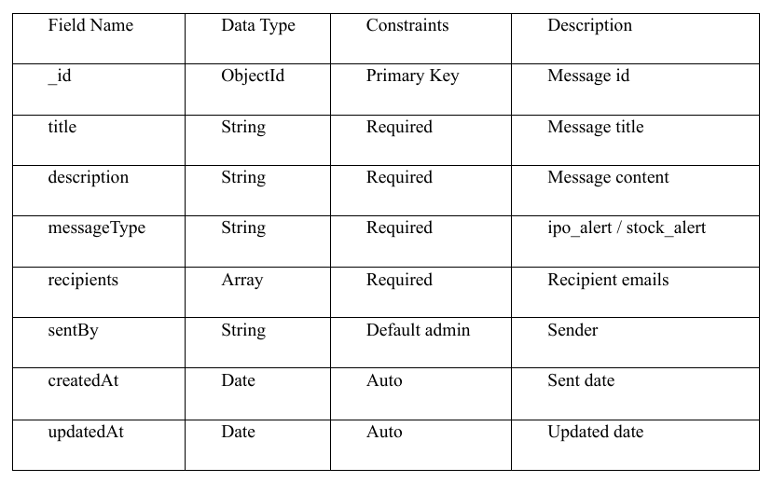

4. Development

4.1. Coding Standards
1. Code Structure & Organization:
● Use component-based architecture where each module and functionality is separated into reusable components.
● Maintain separation of concerns by keeping UI, business logic, API calls, routes, and database operations in separate files.
● Follow modular folder structure for Client Panel:
client/
├── src/
│ ├── modules/
│ │ ├── ipo/
│ │ ├── sip/
│ │ ├── stock/
│ │ └── watchlist/
│ ├── pages/
│ ├── services/
│ ├── shared/
│ ├── App.jsx
│ └── main.jsx
server/
├── config/
├── controllers/
├── models/
├── routes/
├── middleware/
├── services/
├── server.js
└── .env
● Follow similar structured architecture for Admin Panel with dedicated pages, services, layouts, and authentication modules.
2. Naming Conventions:
● Use camelCase for variables, functions, and methods.
Example: getUserPortfolio(), fetchStockData()
● Use PascalCase for React components.
Example: PortfolioCard.jsx, WatchlistTable.jsx
● Use meaningful and descriptive names.
Example: calculateProfitLoss() instead of calc()
3. Code Formatting:
● Follow Prettier and ESLint rules for clean formatting.
● Remove unused variables and debug console logs in production.
● Use template literals instead of string concatenation.
4. React Best Practices:
● Use functional components with hooks such as useState, useEffect, useMemo, and useCallback.
● Use reusable UI components for scalability.
● Apply lazy loading and route-based code splitting where required.
● Use React Router for seamless navigation.
5. API Integration & State Management:
● Use Axios for API requests.
Example: axios.get('/api/stocks')
● Maintain separate service files for all API calls.
● Handle API errors using try-catch blocks.
● Use Context API or modular state handling for shared application state.
● Secure authentication tokens and protected routes properly.
6. Backend Best Practices:
● Use Express.js with separate Routes, Controllers, Models, Middleware, and Services.
● Use MongoDB with Mongoose schemas for structured data management.
● Implement authentication, validation, and role-based authorization.
● Keep environment variables inside .env files.
● Write scalable APIs for Stocks, IPOs, SIP, Portfolio, Watchlist, Notifications, and Admin modules.

4.2. Screen Shots:

Client Panel Screenshots:

Register Page:

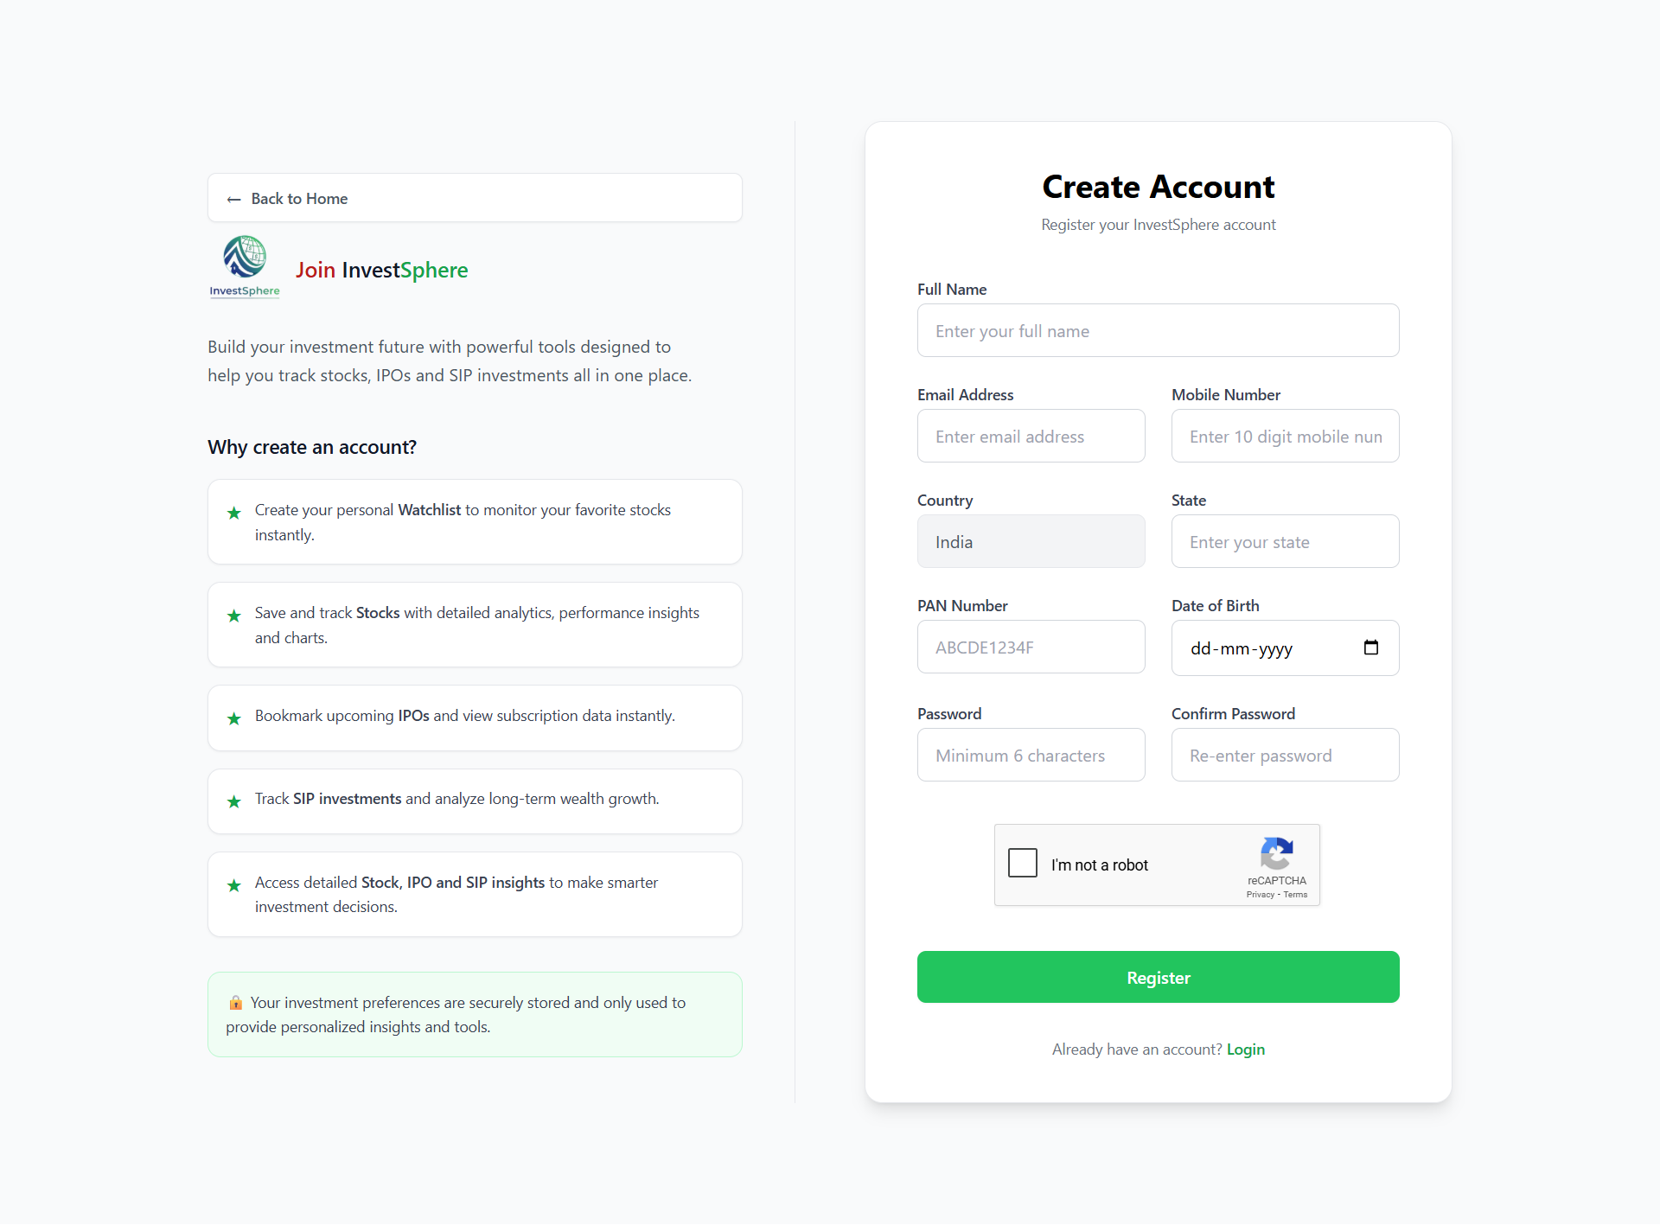

Login Page:

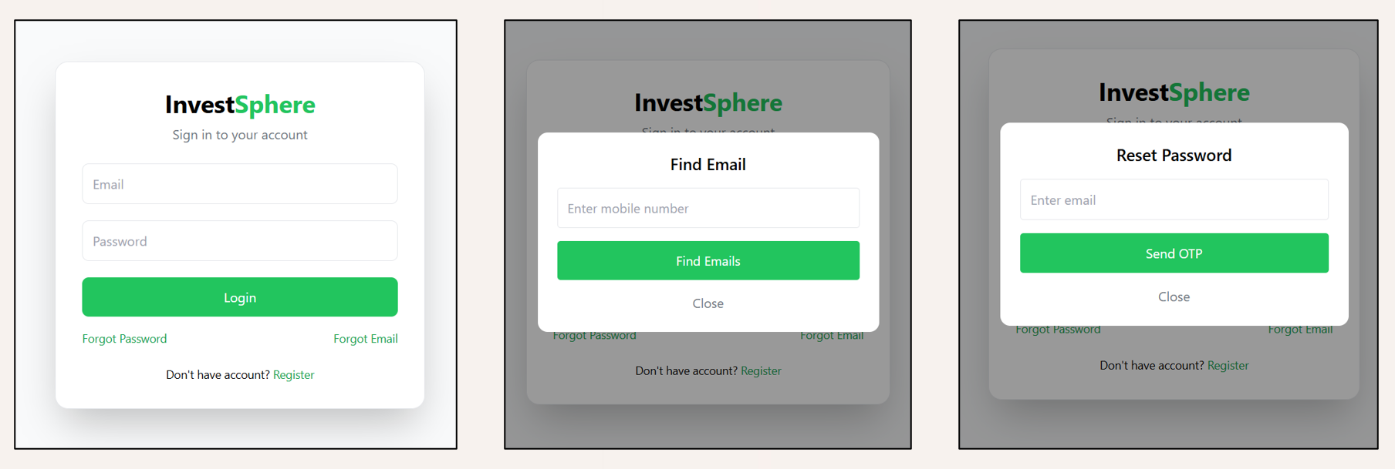

User Profile Page:

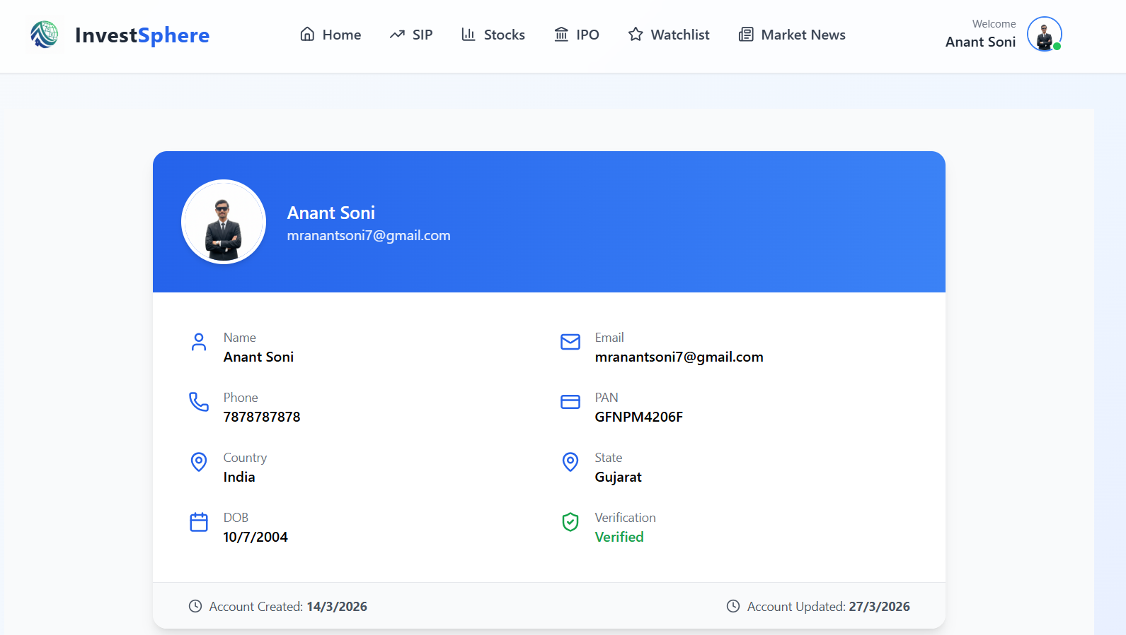

Notification Page:

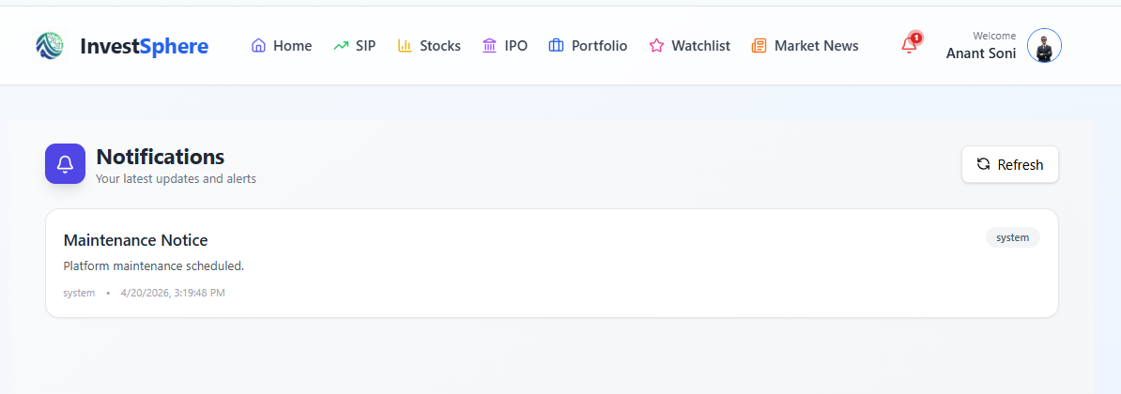

Home Page:

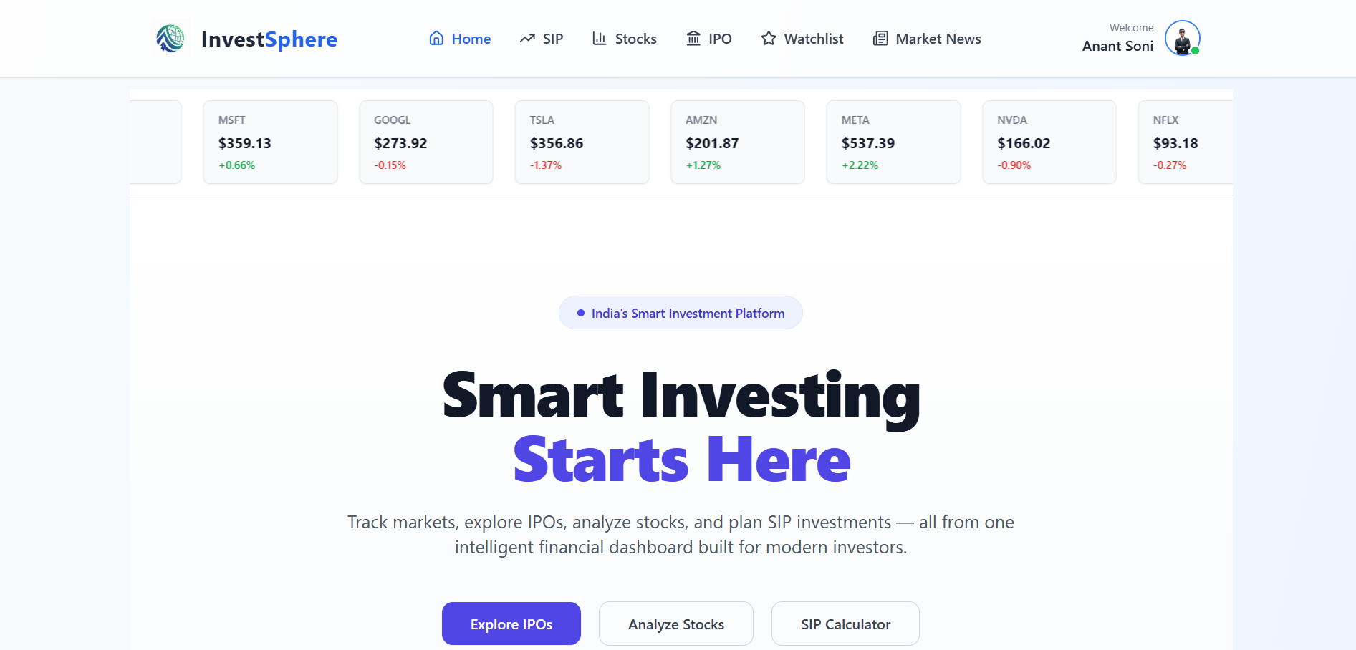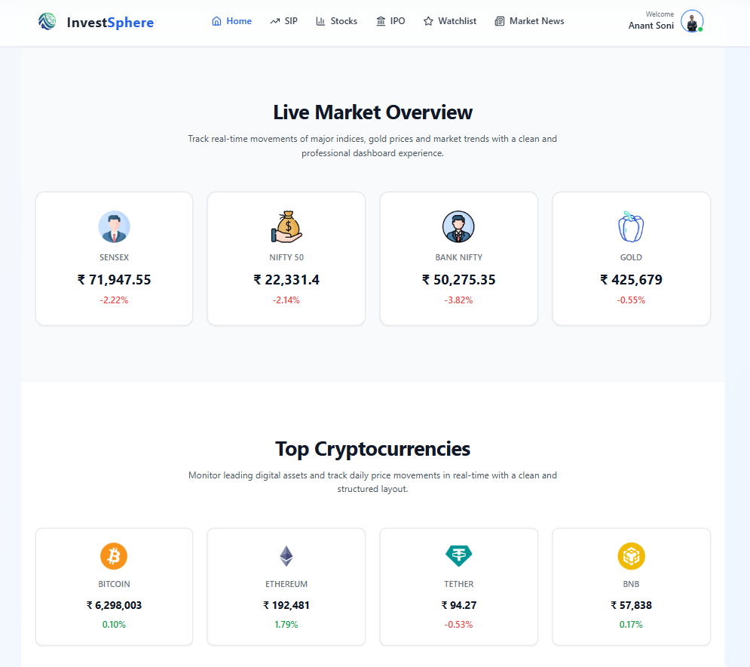

SIP Page:

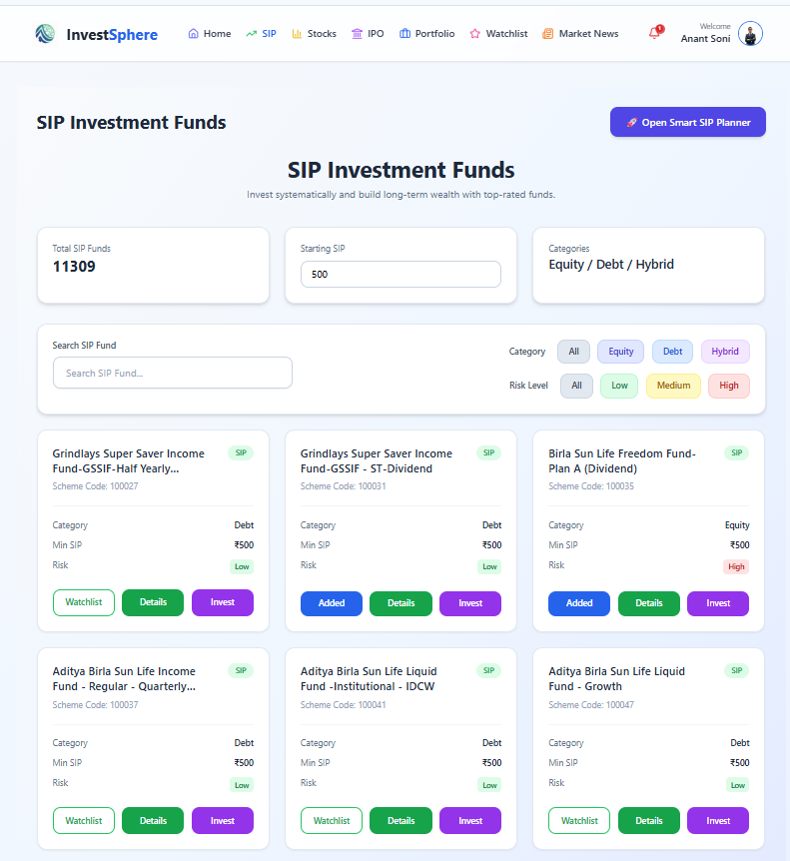
Stock Page:

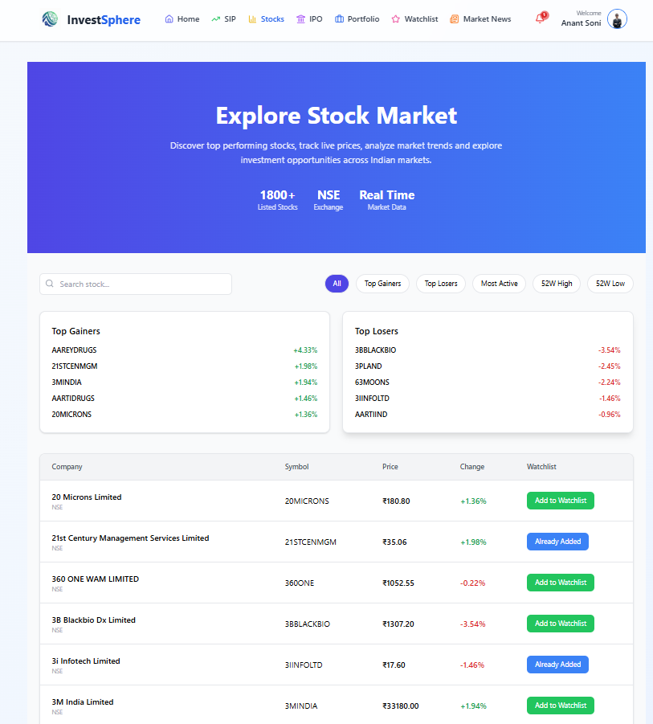

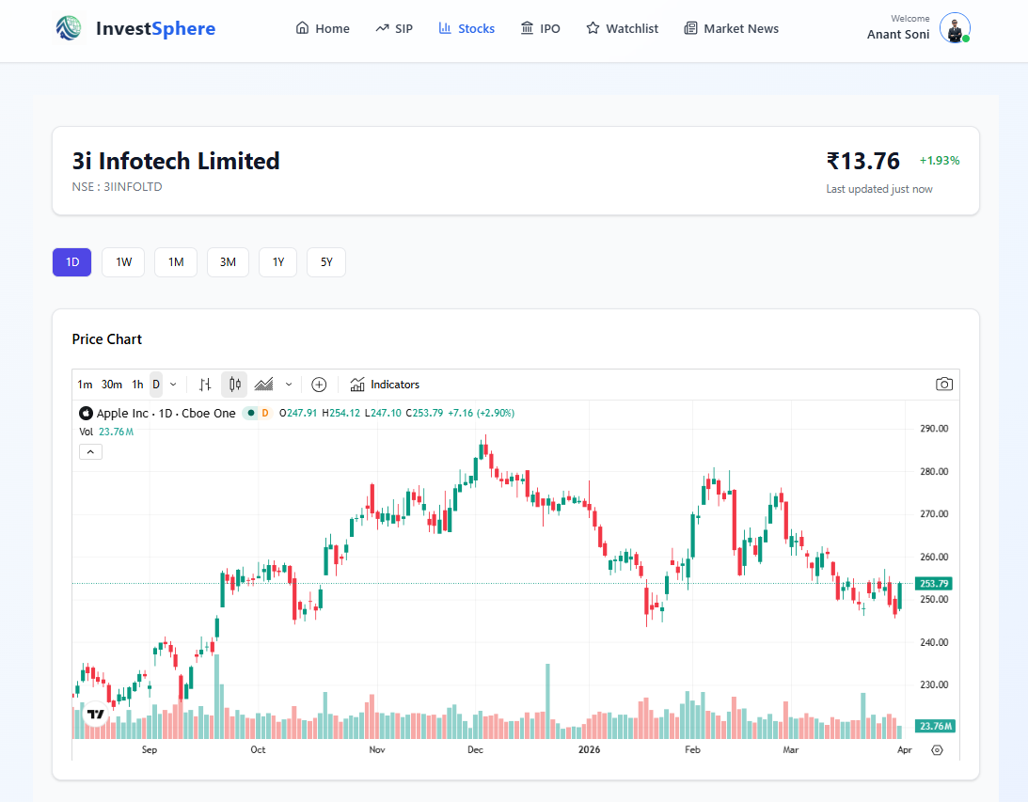

IPO Page:

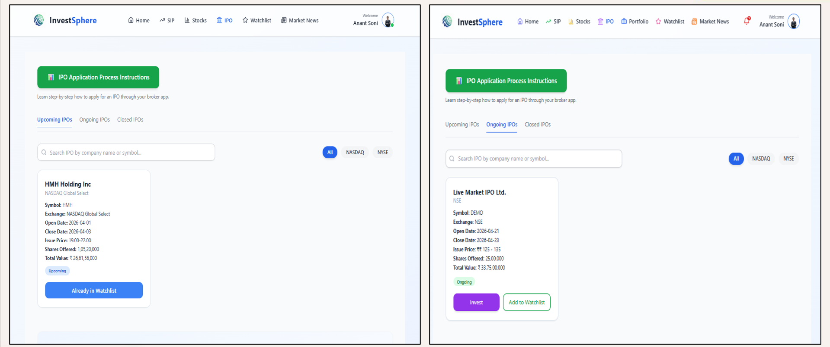

Portfolio Page:

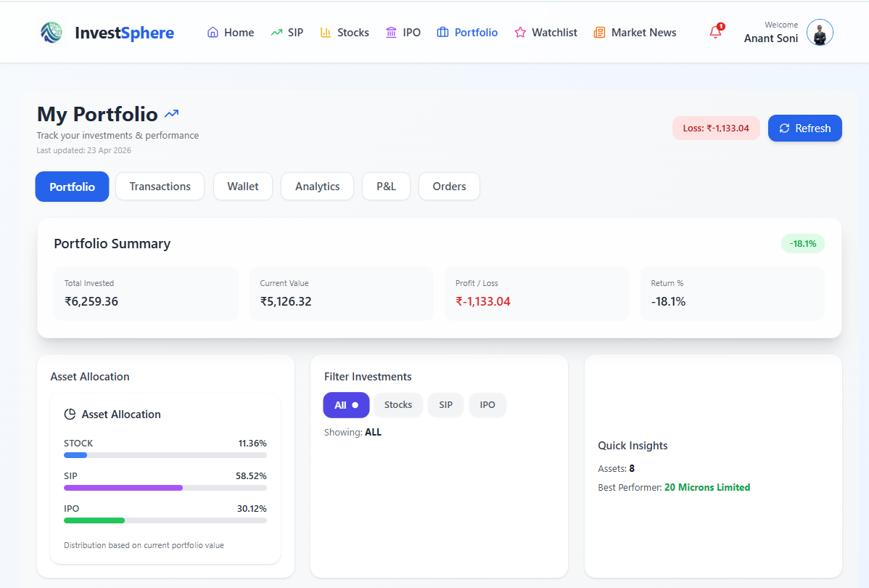

Transaction Page:

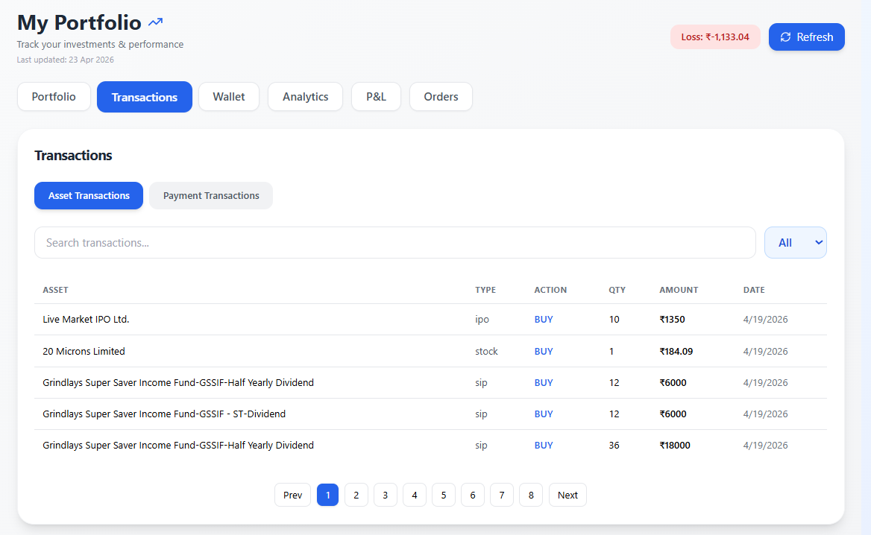

Wallet Page:

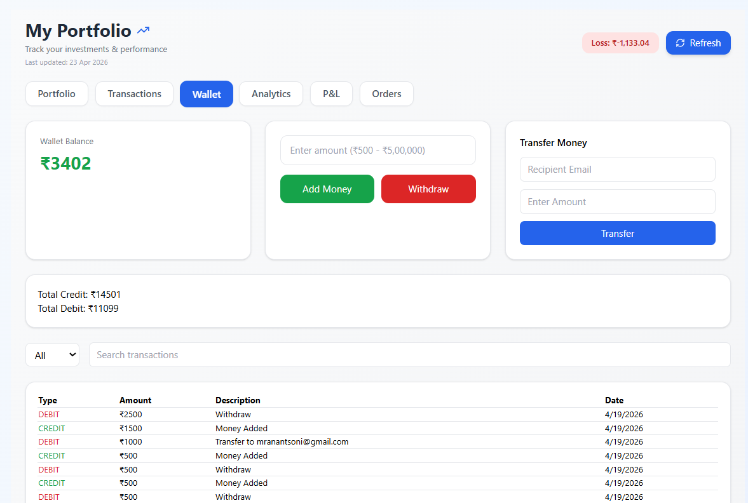

Watchlist Page:

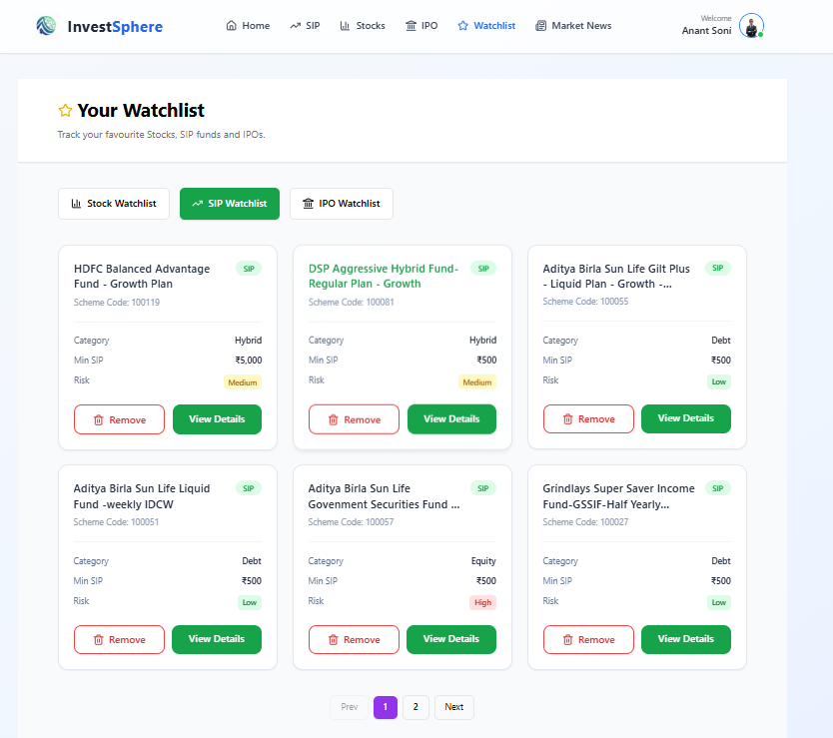

Market News Page:

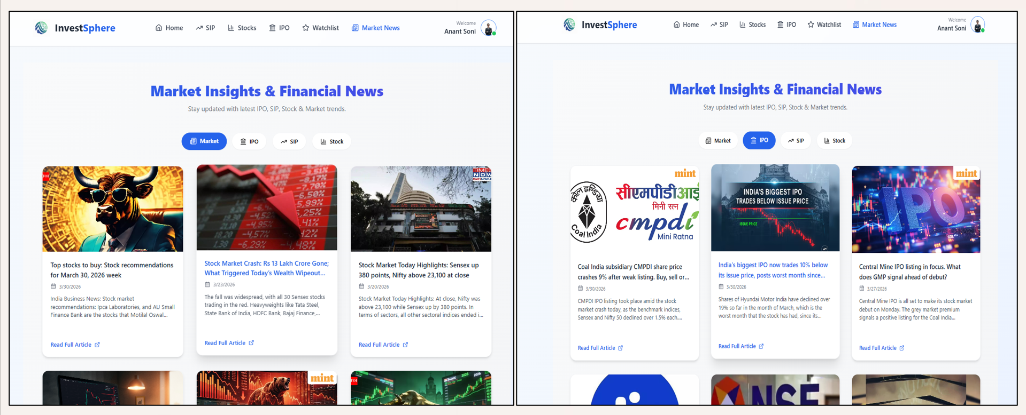

Admin Panel Screenshots:
Admin Dashboard Page:
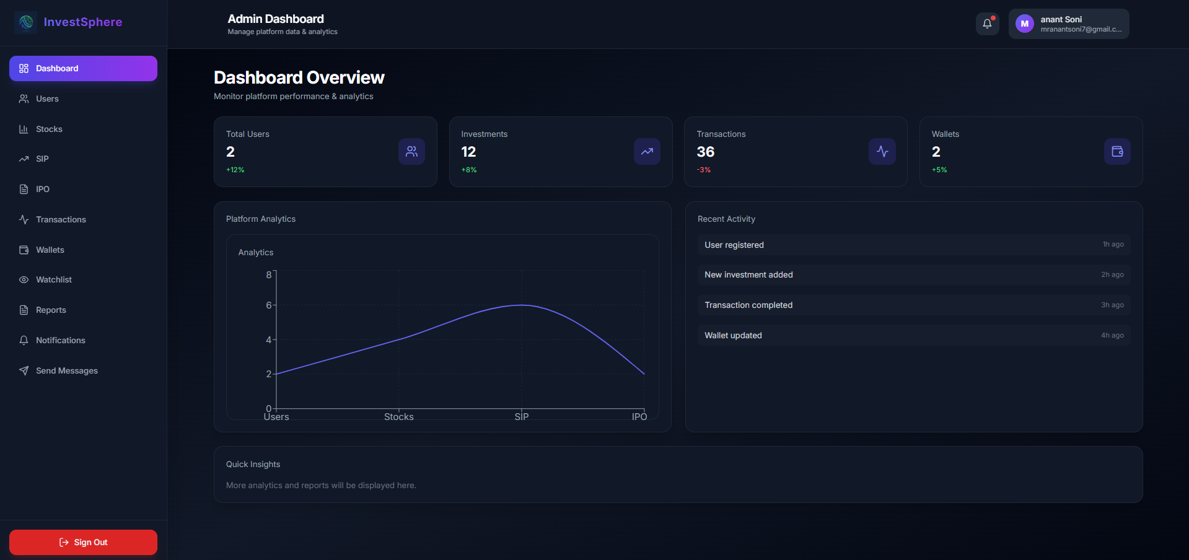
Manage Users Page:
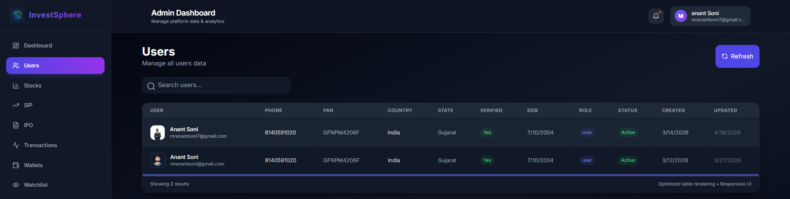

Stocks, SIP, IPO Page:
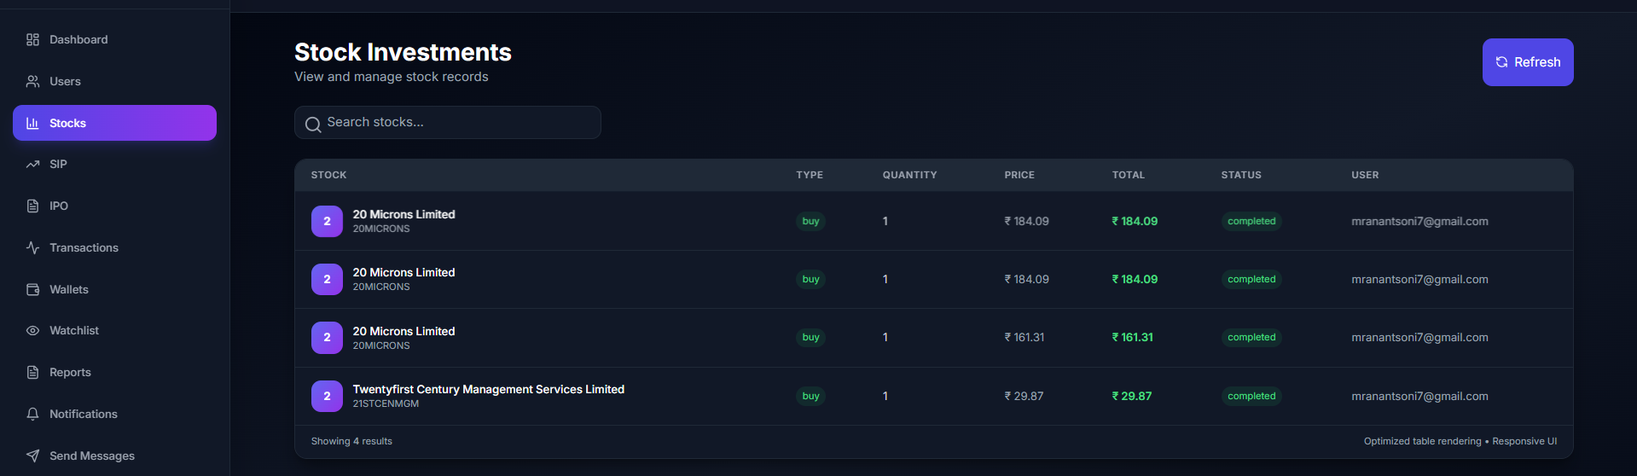
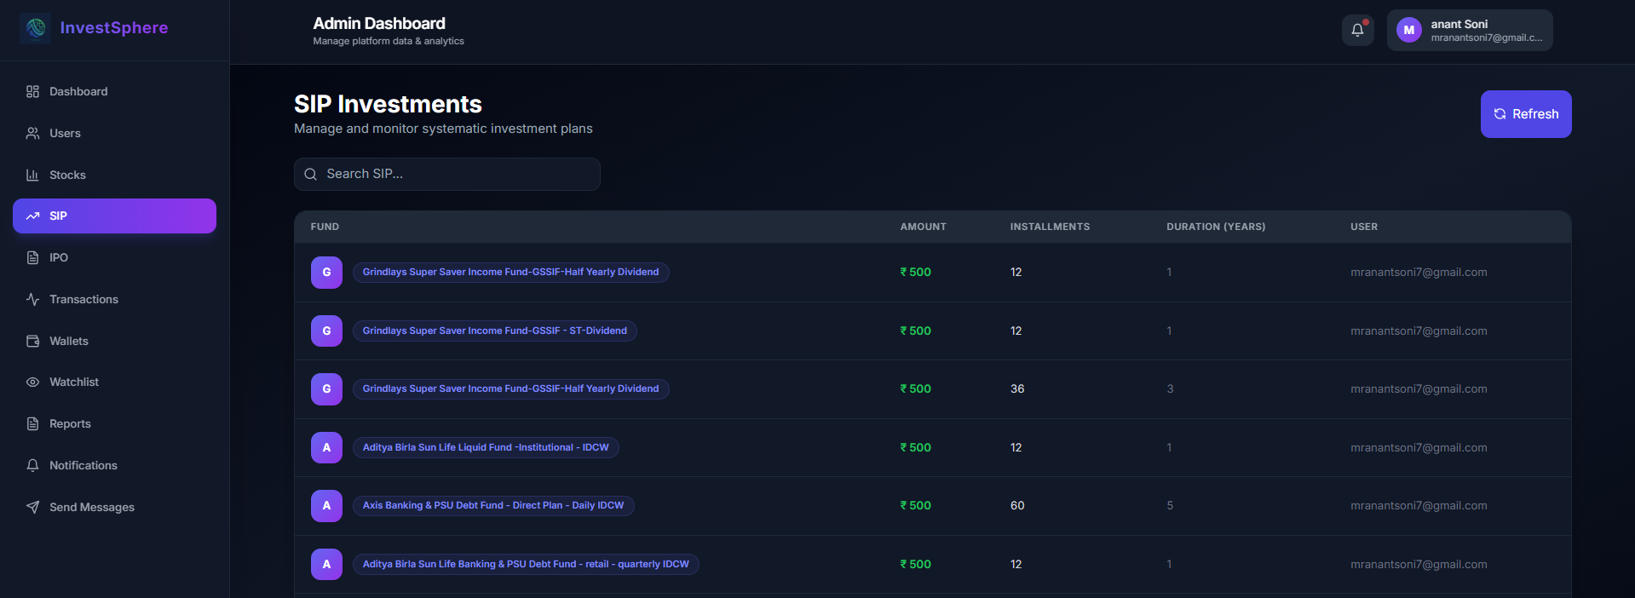
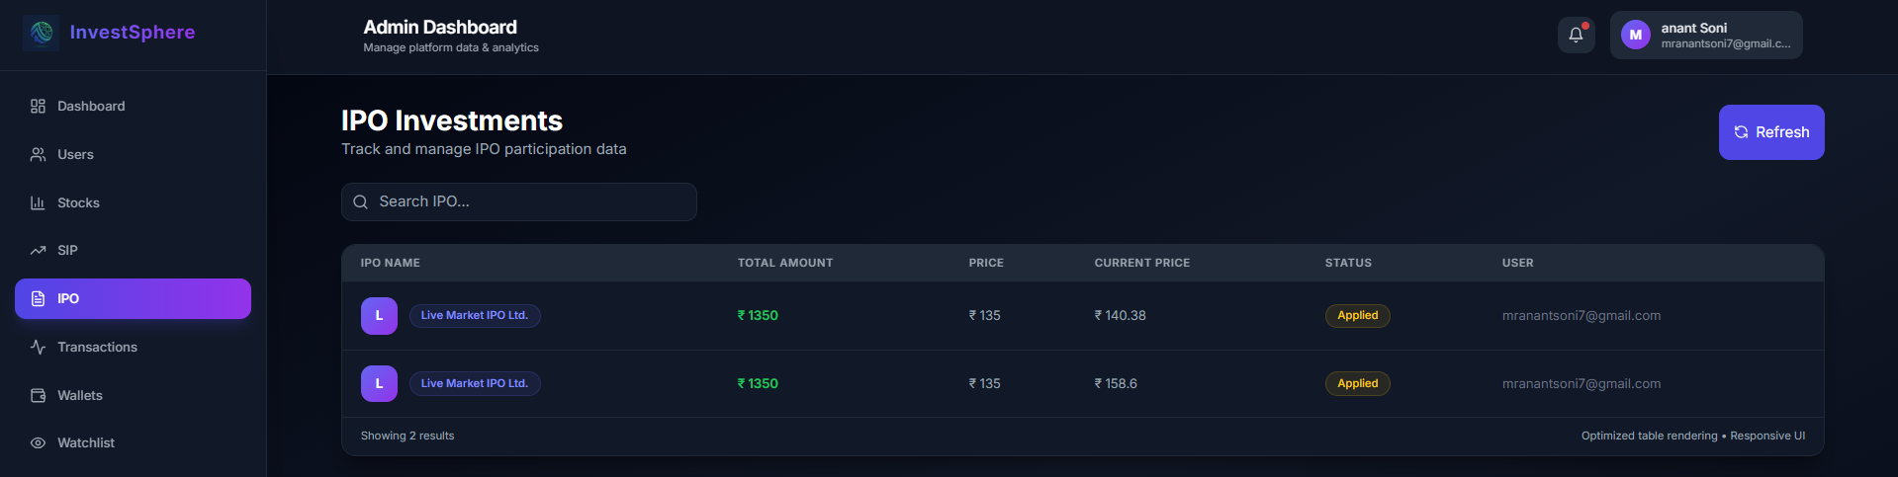
Transaction Page:
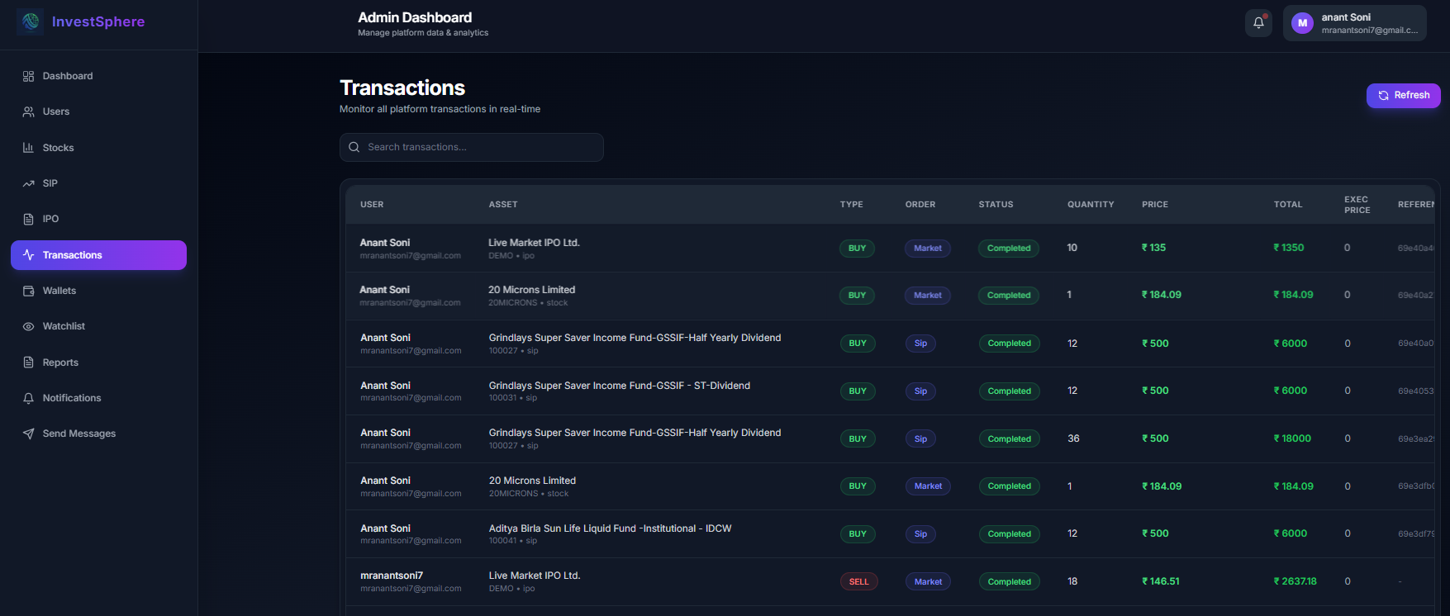
Wallet Page:
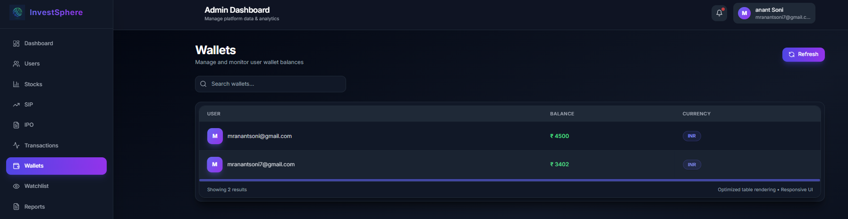
Watchlist Page:
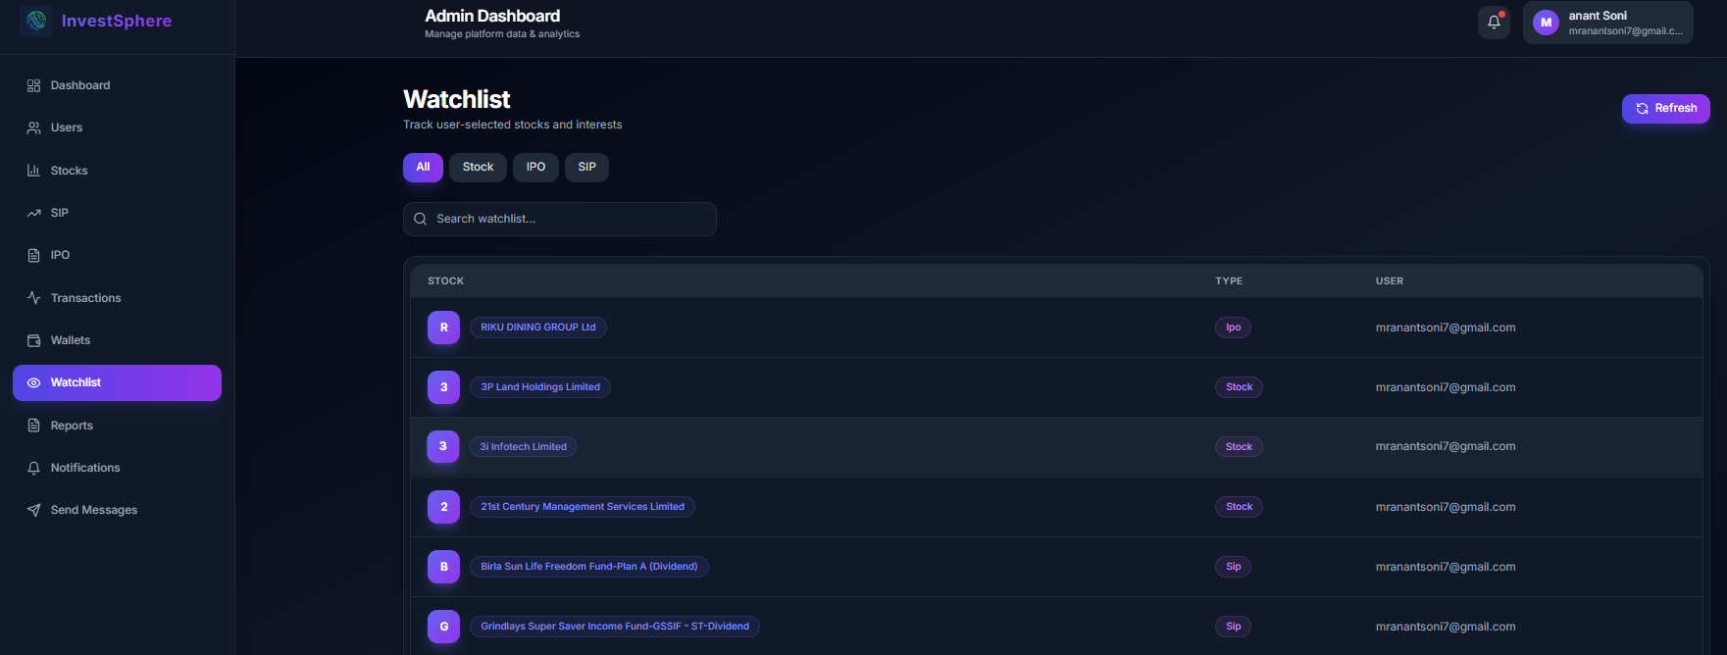
Reports Page:
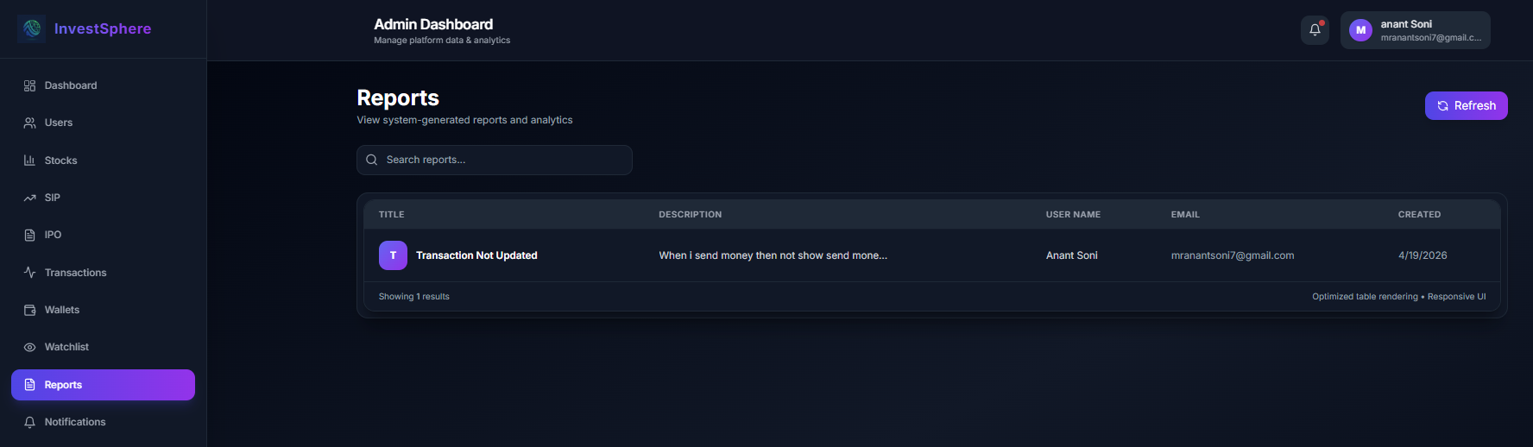
Notifications Page:
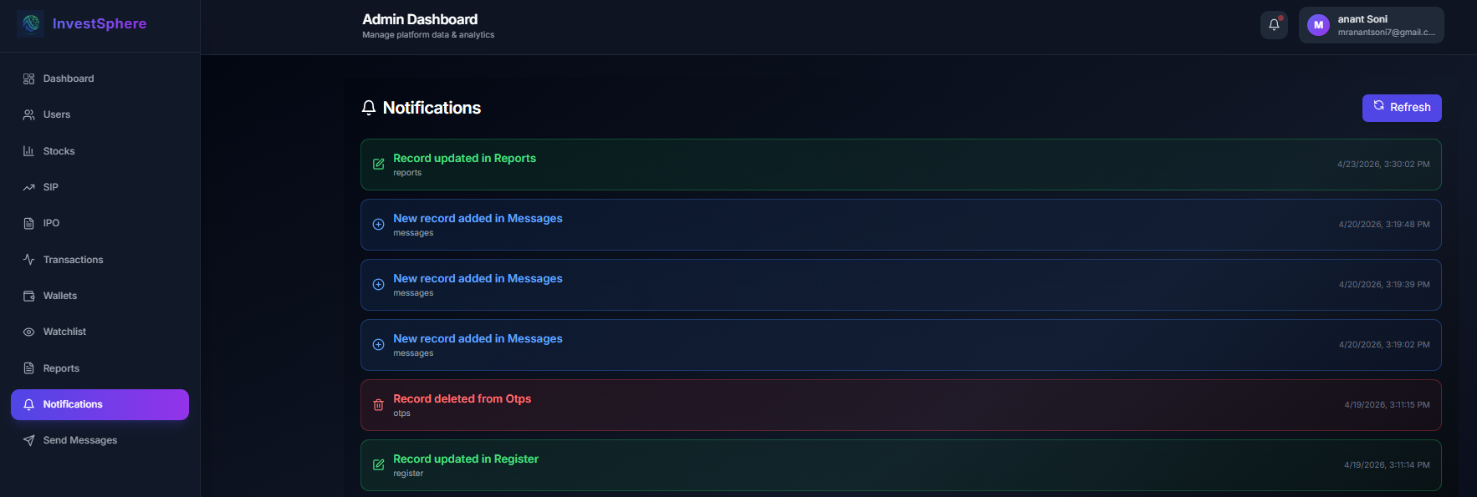
Send Message Page:
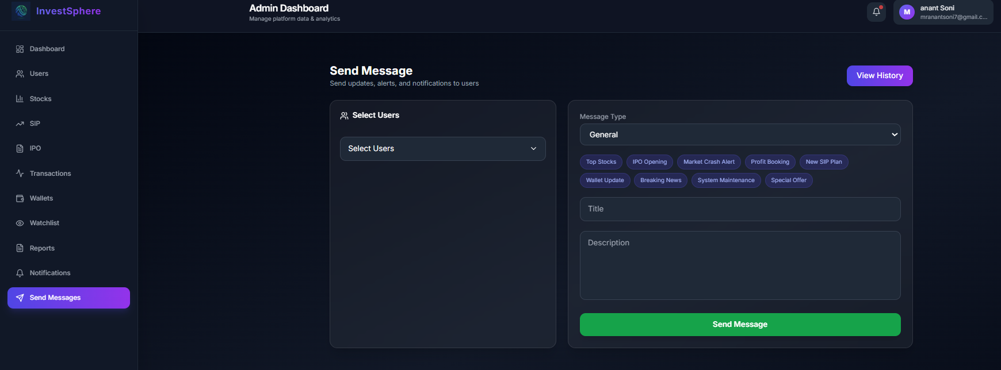

5. Agile Documentation

5.1. Agile Project Charter:
Field | Details
Project Title | InvestSphere
Project Start Date | 19/01/2026
Project End Date | 24/04/2026
Project Scope | MERN Stack based digital investment platform for Stocks, IPO, SIP, Crypto, Portfolio, Watchlist, Admin Panel, Notifications, Authentication, Market APIs integration
Objectives | - Build secure user investment platform - Manage portfolio with buy/sell system - Provide live market data & news - Enable watchlist tracking - Create admin panel for management - Improve user financial experience
Roles Involved | - Full Stack Developer - Frontend Developer - Backend Developer - UI/UX Designer - Tester - Admin User
Key Stakeholders | - End Users / Investors - Project Developer - Admin Team - API Providers - Database / Cloud Services - College / Internship Mentor

5.2. Agile Roadmap / Schedule
Id | Task Name | Start Date | End Date
1 | Project Planning & Research | 19/01/2026 | 10/02/2026
2 | Requirement Gathering | 11/02/2026 | 16/02/2026
3 | UI/UX Design | 17/02/2026 | 27/02/2026
4 | Database Design & Setup | 02/03/2026 | 12/03/2026
5 | Backend Development | 05/03/2026 | 27/03/2026
6 | Frontend Development | 16/02/2026 | 17/04/2026
7 | API Integration | 11/02/2026 | 13/04/2026
8 | Testing & Debugging | 17/03/2026 | 24/04/2026
9 | Deployment & Optimization | 20/04/2026 | 24/04/2026
10 | User Acceptance Testing | 21/04/2026 | 24/04/2026
11 | Final Review & Enhancements | 23/04/2026 | 24/04/2026
12 | Project Submission & Closure | 24/04/2026 | 24/04/2026

5.3. Agile Project Plan
Sprint | Task Name | Start Date | End Date | Days
Sprint 1 | Project Planning & Research | 19/01/2026 | 10/02/2026 | 23
 | Requirement Gathering | 11/02/2026 | 16/02/2026 | 6
 | UI/UX Design | 17/02/2026 | 27/02/2026 | 11
Sprint 2 | Database Design & Setup | 02/03/2026 | 12/03/2026 | 11
 | Backend Development | 05/03/2026 | 27/03/2026 | 23
Sprint 3 | Frontend Development | 16/02/2026 | 17/04/2026 | 61
 | API Integration | 11/02/2026 | 13/04/2026 | 62
Sprint 4 | Testing & Debugging | 17/03/2026 | 24/04/2026 | 39
 | Deployment & Optimization | 20/04/2026 | 24/04/2026 | 5
 | User Acceptance Testing | 21/04/2026 | 24/04/2026 | 4
Sprint 5 | Final Review & Enhancements | 23/04/2026 | 24/04/2026 | 2
 | Project Submission & Closure | 24/04/2026 | 24/04/2026 | 1

5.4. Agile User Story
Case | As a User | I want to | So that I can
1 | As a User | register and login securely using email OTP and password | access my account safely
2 | As a User | explore Stocks, IPOs, SIPs, and Crypto data | find suitable investment opportunities
3 | As a User | add items to watchlist and portfolio | track my investments easily
4 | As a User | view market news, charts, and live data | make better financial decisions
5 | As an Admin | manage users, notifications, and messages | control platform activities efficiently

5.5. Agile Release Plan
Release | Sprint | Start Date | End Date | Features / Tasks | Status
Release 1 | Sprint 1 | 19-Jan-2026 | 27-Feb-2026 | Planning, Research, Requirement Gathering, UI/UX Design | Completed
Release 2 | Sprint 2 | 02-Mar-2026 | 27-Mar-2026 | Database Design, Backend Development, Authentication Setup | Completed
Release 3 | Sprint 3 | 16-Feb-2026 | 17-Apr-2026 | Frontend Development, API Integration, Portfolio Modules | Completed
Release 4 | Sprint 4 | 17-Mar-2026 | 24-Apr-2026 | Testing, Debugging, Deployment, User Acceptance Testing | Completed
Release 5 | Sprint 5 | 23-Apr-2026 | 24-Apr-2026 | Final Enhancements, Review, Project Submission | Completed

5.6. Agile Sprint Backlog
Sprint | Task ID | Task Name | Assigned To | Status | Priority
Sprint 1 | T1 | Project Planning & Research | Full Stack Developer | Completed | High
Sprint 1 | T2 | Requirement Gathering & UI/UX Design | Full Stack Developer | Completed | High
Sprint 2 | T3 | Database Design & Setup | Backend Developer | Completed | High
Sprint 2 | T4 | Backend Development & Authentication | Backend Developer | Completed | High
Sprint 3 | T5 | Frontend Development | Frontend Developer | Completed | High
Sprint 3 | T6 | API Integration & Market Modules | Frontend Developer | Completed | High
Sprint 4 | T7 | Testing & Debugging | QA Engineer | Completed | High
Sprint 4 | T8 | Deployment & User Acceptance Testing | QA Engineer | Completed | Medium

5.7. Agile Test Plan

Testing Phases:

● Unit Testing: Tests individual components such as user authentication, portfolio operations, watchlist management, notifications, and market data modules.

● Integration Testing: Ensures proper data flow between frontend, backend, database, Clerk authentication, Cloudinary, and third-party market APIs.

● System Testing: Verifies complete workflows including user registration, login, investing, portfolio tracking, admin notifications, and profile management.

● User Acceptance Testing: Validates that the platform meets functional requirements and provides a smooth user experience for investors and administrators.

● Performance Testing: Tests response times, API speed, dashboard loading, and platform performance under multiple user requests.

● Security Testing: Ensures user data privacy, secure authentication, protected admin access, encrypted credentials, and prevention of unauthorized access.

Test Cases:

Test ID | Test Scenario | Expected Result | Sprint
1 | Validate user registration with Email OTP verification | User should register successfully after OTP verification | Sprint 1
2 | Verify user login with email and password authentication | User should securely log in to the platform | Sprint 1
3 | Test portfolio buy/sell investment process | Asset should be bought or sold successfully and portfolio updated | Sprint 2
4 | Validate Stocks, IPO, SIP, and Crypto API data integration | Investment data should load correctly on UI pages | Sprint 3
5 | Test watchlist add/remove functionality | Users should add or remove Stocks, IPOs, and SIPs successfully | Sprint 3
6 | Check role-based admin access using Clerk authentication | Only authorized admin should access admin panel | Sprint 4
7 | Test notifications and admin message delivery | Users should receive admin messages in email and notification panel | Sprint 4
8 | Validate deployment, performance, and full system workflow | Platform should run smoothly with stable performance | Sprint 5
  - Earned-value and burn charts:

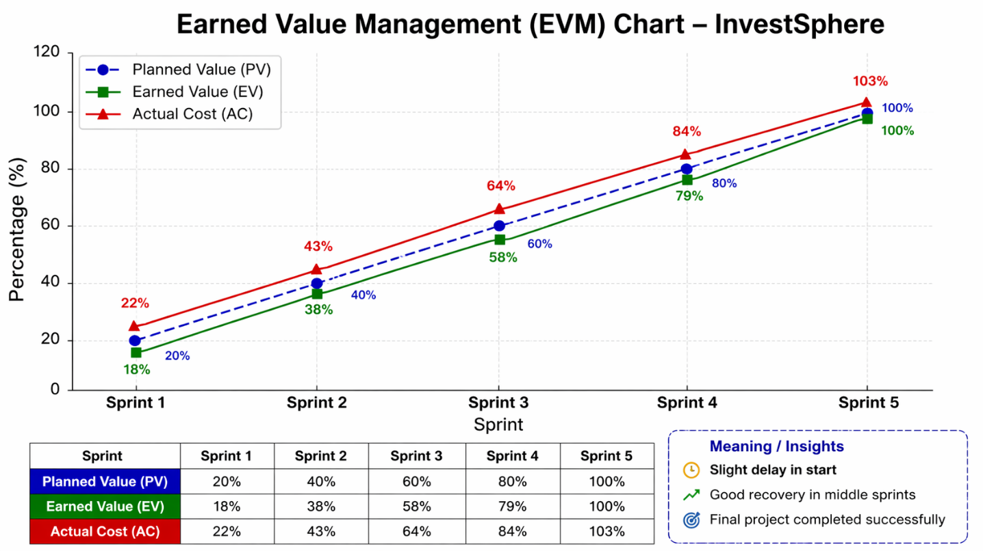

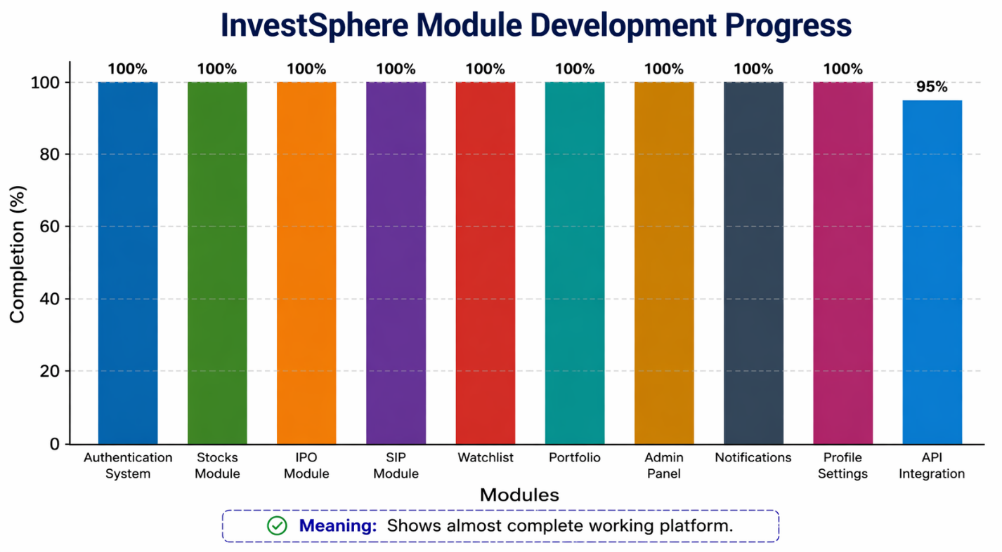

6. Proposed Enhancements

As InvestSphere continues to evolve, several enhancements can be implemented to improve digital investment services, optimize user experience, and provide smarter financial decision-making tools for users and administrators. These enhancements are designed to further streamline platform operations and enhance the overall investing experience.

1. AI-Powered Investment Assistance:

● Implement machine learning models to suggest investment opportunities based on user behavior, portfolio trends, and market conditions.

● Provide predictive analysis and smart recommendations for Stocks, IPOs, SIPs, and diversified portfolios.

2. Automated Alerts & Reminders:

● Introduce email, SMS, and push notifications for IPO openings, stock price targets, SIP due dates, and important market events.

● Enable personalized reminders for watchlist movements and portfolio milestones.

3. Advanced Portfolio Analytics:

● Develop deeper analytics for risk assessment, sector allocation, expected returns, and long-term growth trends.

● Provide visual dashboards for better understanding of portfolio performance.

4. Improved Trading & Investment Experience:

● Introduce faster order execution and smoother asset buy/sell workflows.

● Add real-time chart tools, indicators, and comparison features for better decision-making.

5. Smart Admin Analytics Dashboard:

● Provide real-time data visualization for user growth, active investors, transactions, and platform engagement.

● Enable administrators to analyze user behavior and improve service efficiency.

6. Community & Investor Feedback System:

● Allow users to share ratings, reviews, and feedback on platform features.

● Build trust and engagement through investor insights and community discussions.

7. Multi-Language & Accessibility Support:

● Add regional language support for wider user accessibility.

● Improve platform usability for beginner investors through guided tutorials.

7. Conclusion

InvestSphere is a modern digital investment platform designed to simplify the connection between users and financial markets through seamless online interactions. By providing a structured investment system, secure authentication, and multiple investment options such as Stocks, IPOs, SIPs, and Cryptocurrency, the platform ensures accessible and efficient wealth management services.

The inclusion of portfolio management, watchlists, real-time market updates, analytics, and transaction tracking enhances the overall investment experience. Users benefit from a well-organized dashboard that improves financial planning, portfolio monitoring, and decision-making. The system prioritizes user convenience, performance, and security, making digital investing smoother and more reliable.

Administrators benefit from a structured admin panel that enables efficient user management, notifications, communication, and database monitoring. This improves overall platform operations and ensures better service delivery.

With the potential for future enhancements such as AI-based investment suggestions, predictive analytics, smart alerts, robo-advisory tools, and expanded financial services, InvestSphere remains a forward-thinking FinTech solution. By leveraging modern technology, the platform continues to evolve, making investing more accessible, organized, and efficient for all users.

8. Bibliography

API References & Integrations

1. Crypto API : https://api.coingecko.com/api/v3/coins/markets

2. IPO Data API : https://finnhub.io/api/v1/calendar/ipo

3. Stock Market Data API : https://query1.finance.yahoo.com/v8/finance/chart

4. SIP / Mutual Fund API : https://api.mfapi.in/mf

5. Market News API : https://gnews.io/api/v4/search

6. NSE Stock List Data : https://archives.nseindia.com/content/equities/EQUITY_L.csv

7. Cloudinary (Image Storage) : https://console.cloudinary.com/

Additional Reference Platforms

1. Groww : https://groww.in/

2. Angel One : https://www.angelone.in/

3. Moneycontrol : https://www.moneycontrol.com/

4. Yahoo Finance : https://finance.yahoo.com/

5. Upstox : https://upstox.com/

Development Tools Used

1. React.js : https://react.dev/

2. Tailwind CSS : https://tailwindcss.com/

3. Node.js : https://nodejs.org/

4. Express.js : https://expressjs.com/

5. MongoDB Atlas : https://www.mongodb.com/atlas

6. Clerk Authentication : https://clerk.com/

7. Postman : https://www.postman.com/

8. Axios : https://www.npmjs.com/package/axios

